SOCIAL CONNECT AND RESPONSIBILITY

ADITYA COLLEGE OF ENGINEERING AND TECHNOLOGY

Affiliated Visvesvaraya Technological University (VTU) Approved by AICTE New Delhi Kamakshipura,
Hesarghatta Main Road Rajankunte, Yelahanka, Bengaluru -560089

Group: Siddalingayya, Venkatesh Kumar, Vaibhav, Basavaraj, Vinay S S
Student Name: Siddalingayya
USN: 1DI24CS070
Module No.: 01
Tittle: PLANTATION AND ADOPTION
Name of the course coordinator: Prof. Charan

Date | Time | Main point of the day
20-11-25 | 10.00 am  To  2.00 pm | 1. Choose the plant.  2. Planted in the College to  ensure the Social  Responsibility in maintaining  the college environment as  green.

Dept Of CSE

Module1

PLANTATION AND ADOPTION

Introduction
Jasmine, a genus in the Oleaceae family, comprises over 200 species of flowering plants known for their strong, sweet fragrance. Native to tropical and subtropical regions of the world, including Europe, Asia, and Africa, jasmine is highly prized for its aromatic flowers. The flowers can be white, yellow, or pink, and are widely cultivated for ornamental purposes, as well as for their essential oils, which are used in the perfume industry. Additionally, jasmine holds cultural and medicinal significance in various parts of the world.
The name "jasmine" is derived from the Persian word "gift from God," reflecting its long- standing value in various cultures. The plant is historical cultivation spans thousands of years, with early records from the Middle East, India, and Egypt. In this section, we will explore the various aspects of jasmine, from its practices.
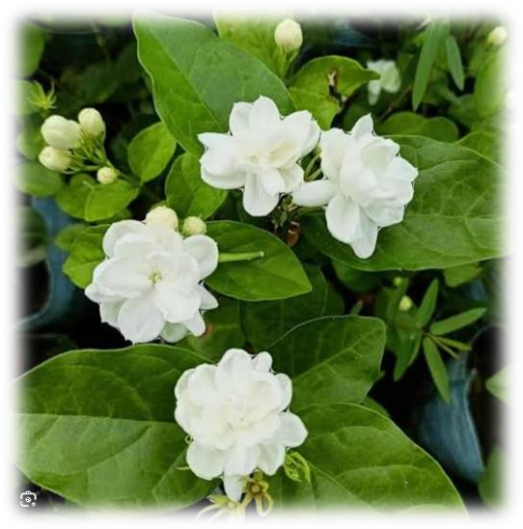
Figure1.1 Jasmine Flower

Description
Jasmine plants exhibit a variety of growth forms, from small shrubs to sprawling vines. Depending on the species, they can be found growing as creeping groundcovers, large shrubs, or even as trees. The flowers are the most notable feature of the jasmine plant, with their distinct, star-shaped structure and enchanting scent.

Botanical Characteristics:
    - Size: Jasmine plants can vary widely in size. Some species grow as small shrubs while others, like Jasminum officinale, are fast-growing vines that can reach up to 10 feet in length when trained.

    - Leaves: The leaves are typically glossy, ovate or lance-shaped, and can be either evergreen or deciduous, depending on the climate and species. In many varieties, the leaves are aromatic when crushed.
    - Flowers: Jasmine flowers are the highlight of the plant, usually consisting of five or more white or yellow petals that form a star-shaped bloom. These flowers are arranged in clusters and exude a strong, sweet fragrance. The flowering period depends on the climate, but jasmine generally blooms during the warmer months.
    - Fruits: After flowering, jasmine produces small, berry-like fruits, although these are generally not consumed. The primary value of jasmine lies in its flowers and the oils extracted from them.

Fragrance: Jasmine flowers are famous for their intense fragrance. The scent is particularly potent in the evening and at night, making it a favorite among nocturnal pollinators like moths. This fragrance has led to jasmine’s widespread use in the perfume industry.
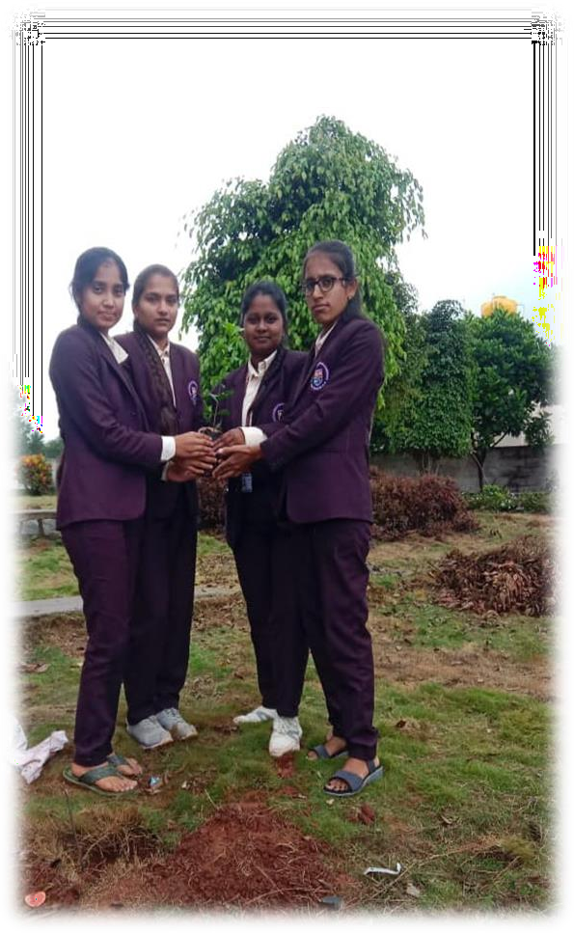
Figure1.2: Jasmine sampling

Plant Growth
Jasmine plants grow in a range of climates, from temperate to tropical regions, with specific care requirements that vary depending on species. The growth of jasmine can be understood by examining its soil, water, light, and temperature needs.

Ideal Growing Conditions:
    - Climate: Jasmine plants prefer warm climates with temperatures between 60°F (15°C) and 75°F (24°C). They thrive in regions with moderate to high humidity but may not tolerate extreme cold.
    - Soil: Well-draining, fertile soil is essential for jasmine. It grows best in slightly acidic to neutral soils (pH 6.0–7.0). Sandy loam or loamy soils are ideal, as they provide the necessary drainage while holding enough moisture for the roots.
    - Watering: Jasmine plants require regular watering, especially during their active growing season. The soil should be kept consistently moist, but overwatering should be avoided to prevent root rot. The plant prefers soil that is moist but not soggy.
    - Sunlight: Jasmine plants require full sun to partial shade to thrive. At least 4-6 hours of direct sunlight daily is necessary for optimal flowering. Vining jasmine varieties, like Jasminum officinale, benefit from a support structure, such as a trellis, to grow upwards and encourage blooms.
    - Temperature and Humidity: Jasmine thrives in temperatures between 60°F (15°C) and 75°F (24°C). In colder climates, jasmine may need to be grown indoors or in a greenhouse during the winter. Regular misting can help maintain the plant’s humidity levels in dry environments.

Growth Stages:
      - Germination: Jasmine can be propagated from seeds, although it’s more commonly grown from cuttings. When growing from seed, jasmine requires patience, as it can take time to establish itself.
      - Vegetative Growth: In this stage, jasmine focuses on growing its leaves and stems. Regular pruning helps manage its size and encourages more flowering.
      - Flowering: Jasmine typically starts to flower once the plant reaches maturity. Proper care, including feeding and pruning, promotes healthy blooming. Depending on the species, jasmine can bloom throughout the year, although spring and summer are common blooming seasons.
      - Mature Plant: As the plant matures, it requires periodic pruning to ensure it maintains a compact, healthy shape. Regular deadheading (removal of spent flowers) encourages further bloom.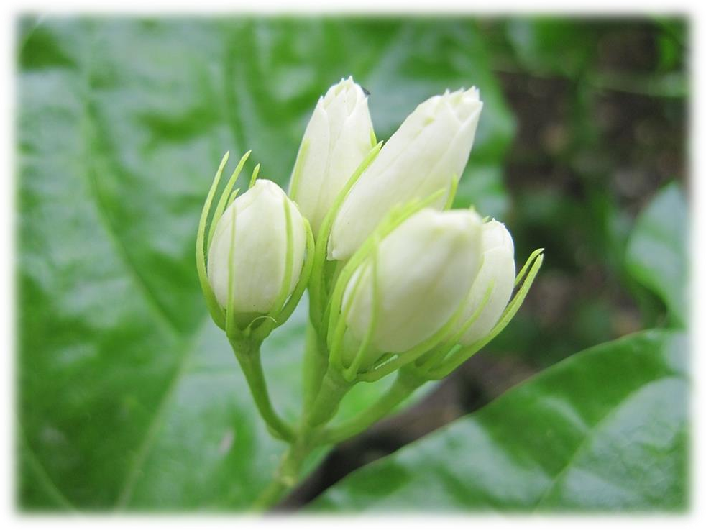
Figure1.3: Jasmine plant growth

Early Cultivation
Jasmine has been cultivated for thousands of years, with its origins traced back to ancient regions of Asia, the Middle East, and Europe. The plant's rich history of cultivation spans multiple civilizations and cultures.

Historical Significance:
    - Ancient Egypt: Jasmine was highly valued in ancient Egypt for its fragrance and used in cosmetics and perfumes. Jasmine flowers were associated with the goddess Isis, symbolizing beauty and fertility. It was also utilized in religious ceremonies.
    - India: In India, jasmine has been cultivated for over 2,000 years. It is an essential part of Indian culture, particularly in religious ceremonies, where jasmine flowers are used to make garlands for deities. The flower is also used in weddings and is seen as a symbol of purity, love, and devotion.
    - Persia and the Middle East: Jasmine’s cultivation spread to Persia, where it was highly prized for its sweet fragrance. In ancient Persia, jasmine was used for its medicinal properties, particularly as a treatment for headaches and anxiety.
    - Ancient Greece and Rome: In these civilizations, jasmine was used for both medicinal and aesthetic purposes. It was valued for its scent and was used in perfumes. Jasmine's calming and relaxing properties were also recognized in early herbal medicine.

Spread to Europe:
By the 17th century, jasmine had spread to Mediterranean countries, where it became an integral part of garden design. It was also cultivated extensively in France, particularly in the region of Grasse, which became the perfume capital of the world. The French began cultivating jasmine specifically for its essential oils, which were used in high-end perfumes.

Modern Cultivation:
Jasmine is now grown in many countries across the globe. In addition to its ornamental uses, jasmine continues to be a major contributor to the perfume industry. Countries like India, Egypt, and Morocco are significant producers of jasmine flowers and jasmine oil. The plant has been integrated into various agricultural practices, especially in regions with suitable climates for its growth.
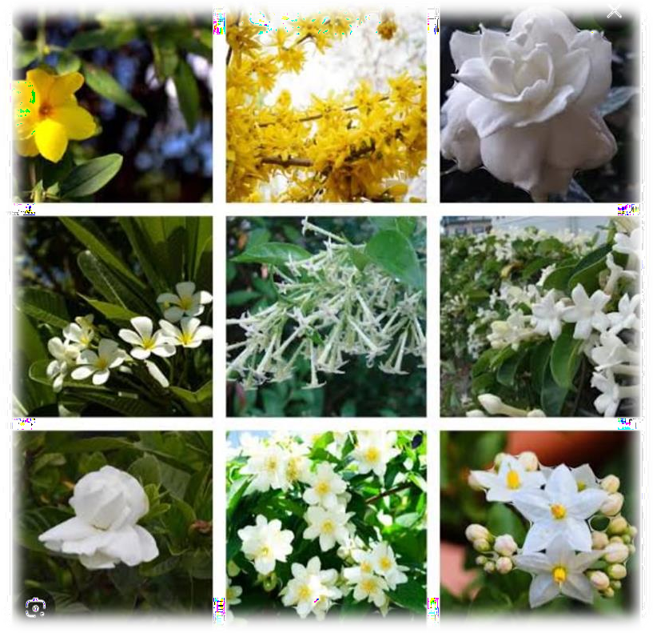
Figure1.4: different types of jasmine flowers

Nutrition
To grow healthy jasmine plants that produce abundant flowers, it is essential to provide the right nutrients. The plant’s nutritional needs are best met through a balanced approach to soil preparation, fertilization, and watering.

Essential Nutrients:
    - Macronutrients:
- Nitrogen (N): Nitrogen is essential for vegetative growth, contributing to leaf and stem development. While nitrogen is necessary for jasmine, excessive amounts can result in lush foliage with fewer flowers.
- Phosphorus (P): Phosphorus is critical for strong root development and flower production. It encourages the plant to produce more blooms, making it an essential nutrient for jasmine.
- Potassium (K): Potassium is necessary for flower development and overall plant health. It strengthens the plant’s disease resistance and helps regulate water uptake in the plant’s cells.

Micronutrients:
- Magnesium (Mg): Magnesium aids in photosynthesis and helps the plant produce strong, healthy leaves.
- Calcium (Ca): Calcium contributes to strong cell walls and overall plant strength.
- Iron (Fe): Iron is necessary for chlorophyll production, which gives the plant its green colour and aids in photosynthesis.

Fertilization:
    - Jasmine benefits from regular fertilization, particularly during its growing and flowering seasons. A balanced fertilizer with equal parts of nitrogen, phosphorus, and potassium (NPK) is ideal for promoting overall plant health.
    - Organic Fertilizers: Compost and well-rotted manure are excellent organic options for jasmine. These provide slow-released nutrients and improve soil structure.
    - Slow-Release Fertilizers: Slow-release fertilizers, especially those high in phosphorus, are best used during the flowering period to encourage abundant blooms.
    - Foliar Feeding: Jasmine can also benefit from foliar feeding, where liquid fertilizers are sprayed directly onto the leaves, providing a quick nutrient boost.

Soil Amendments:
    - Jasmine prefers slightly acidic to neutral soils (pH 6.0 to 7.0). Adding organic material like compost can improve soil structure and increase nutrient availability.
    - Well-drained soil is essential for preventing root rot. In areas with heavy clay soil, it is recommended to add sand or organic matter to improve drainage.

Uses
Jasmine has a wide array of uses across various industries, including ornamental gardening, medicinal purposes, culinary practices, and in the production of essential oils for the perfume industry.

Ornamental Use:
Jasmine is widely cultivated as an ornamental plant due to its aesthetic and aromatic properties. It is used in garden design, both as a ground cover and as a climbing plant. Jasmine vines can be trained to grow on trellises, and fences, providing a beautiful and fragrant display.

Medicinal Uses:
Jasmine has a long history of use in traditional medicine:
    - Aromatherapy: Jasmine essential oil is known for its relaxing and mood-lifting properties. It is often used to reduce anxiety and stress and is incorporated into aromatherapy treatments.
    - Digestive Health: Jasmine tea is known to aid digestion and relieve symptoms of indigestion and nausea. It has been used in some cultures as a natural remedy for upset stomachs.
    - Pain Relief: Jasmine flowers have been used in traditional remedies for headaches and menstrual pain. Some studies suggest that the flower's calming properties may help alleviate pain and discomfort.

Culinary Uses:
Jasmine is also used in the culinary world, particularly in the form of jasmine tea. The plant’s leaves and flowers can be dried and infused in hot water to create a fragrant and calming beverage. Jasmine is also used in some desserts and as a favouring for rice dishes, particularly in Asian cuisine.

Perfume Industry:
Jasmine’s primary commercial value lies in its use in the perfume industry. The oil extracted from jasmine flowers, known as absolute jasmine, is highly valued for its sweet, floral fragrance. Jasmine is a key ingredient in many high-end perfumes and colognes. The flower

are harvested in the early morning, before sunrise, to capture their full fragrance.
Figure 1.5: Jasmine flower

Conclusion
Jasmine is a versatile and valuable plant that has captured the hearts and minds of people around the world for centuries. Its aesthetic appeal, rich fragrance, and numerous uses in medicine, perfume, and cuisine ensure that it remains a plant of great cultural, economic, and ecological importance.
From its historical roots in ancient civilizations to its modern-day significance in various industries, jasmine continues to be cherished for its beauty and utility. As we continue to explore and utilize jasmine’s diverse properties, the plant’s importance in human culture and well-being will only grow.
In conclusion, jasmine is more than just a beautiful flower—it is a symbol of love, purity, and relaxation, a source of economic prosperity, and a testament to the interconnectedness of nature and human civilization.
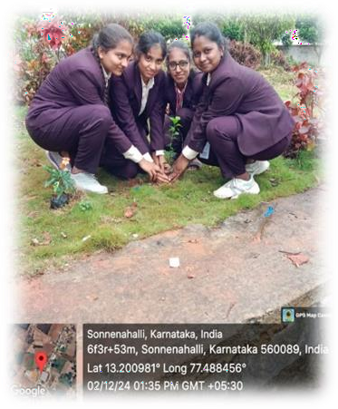

Figure1.7: Planting the Sampling

SOCIAL CONNECT AND RESPONSIBILITY

ADITYA COLLEGE OF ENGINEERING AND TECHNOLOGY

Affiliated Visvesvaraya Technological University (VTU) Approved by AICTE New Delhi Kamakshipura,
Hesarghatta Main Road Rajankunte, Yelahanka, Bengaluru -560089

Group: Siddalingayya, Venkatesh Kumar, Vaibhav, Basavaraj, Vinay S S
Student Name: Vinay S S
USN: 1DI24CS087
Module No.: 02
Tittle: HERITAGE WALK AND CRAFTS CORNER
Name of the course coordinator: Prof. Charan

Date | Time | Main point of the day
26-11-25 | 9.00 am  To  2.00 pm | - Visiting Madurai temple located in Bengaluru.  2.Exploring the place.

Dept Of CSE

Module 2

HERITAGE WALK AND CRAFTS -CORNER

Introduction
Bengaluru, the capital city of Karnataka, is a bustling metropolis with a rich cultural history, blending traditional craftsmanship with modern development. This section will provide an introduction to the importance of Bengaluru’s heritage walk and craft traditions, offering a glimpse into the city's unique cultural and historical legacy.
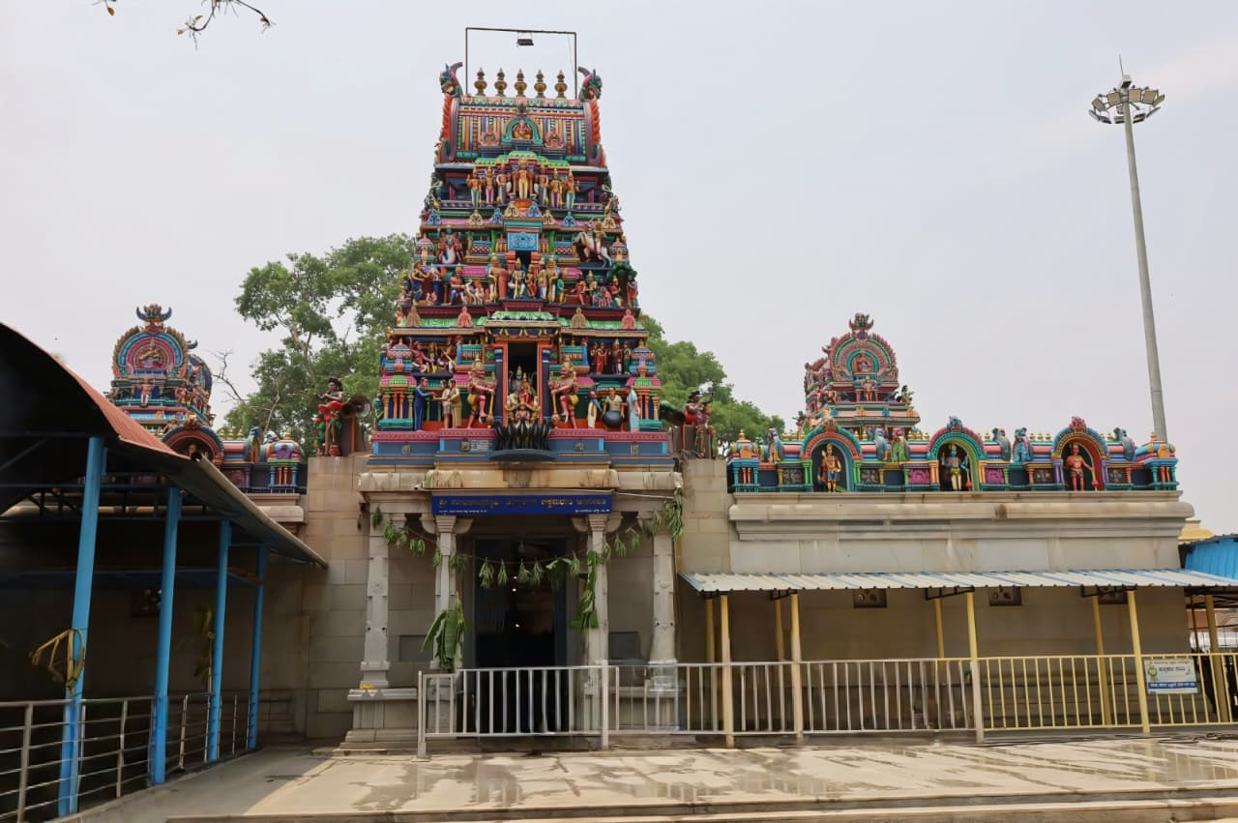
Bengaluru's heritage walk is a journey through time, taking visitors through historical landmarks, ancient temples, and the remnants of colonial architecture. The crafts corner, on the other hand, showcases the city's deep-rooted traditions in arts, crafts, and textiles that have been preserved over generations. This module explores some of the most iconic aspects of Bengaluru’s heritage, including the Chikka Madhure temple Bengaluru, the exquisite Bengaluru silk.

Figure 2.1: Bengaluru city

Etymology
The name "Bengaluru" is derived from the Kannada language, the official language of Karnataka. The term is believed to have originated from "Benda Kal," which means "the town of boiled beans." According to legend, a 9th-century ruler named King Veera Ballal of the Hoysala dynasty visited the area and was offered a simple meal of boiled beans by a local
woman. In gratitude, he named the place "Benda kal which eventually evolved into "Bengaluru."
The city's name has undergone various transformations over the centuries, from "Bengaluru" to "Bangalore" under British colonial rule and finally back to "Bengaluru" in 2006 to reflect its original pronunciation in Kannada. The etymology of the city reflects its agricultural past and long-standing connection to the local people and their traditions.



Figure2.2: Chikka Madhure temple

Culture
Bangalore Bengaluru is a melting pot of diverse cultures, a blend of ancient traditions and modern influences. It is known for its cosmopolitan nature, with people from all over India and the world calling it home. The city’s culture is deeply influenced by its history, architecture, cuisine, and arts.
- Festivals: Bengaluru celebrates numerous festivals, including traditional Hindu festivals like Diwali and Makar Sankranti. The city also hosts cultural events like the Bengaluru Karaga, a festival unique to the city, celebrated with processions, dances, and rituals.
- Music and Dance: Bengaluru has a rich tradition of classical music, especially Carnatic music, as well as classical dance forms like Bharatanatyam. The city is home to various cultural organizations and holds annual festivals such as the Habba, which showcase both traditional and contemporary music and dance.

- Cuisine: Bengaluru’s cuisine is also a reflection of its diverse culture. From traditional South Indian dishes like dosa, and vada to cosmopolitan food from all over the world, the city offers an extensive array of flavours and culinary experiences.

Chikka Madhure Temple Bengaluru
On the banks of the Madhure Kere Lake in Chikka Madhure in Kanaswadi is one of the famous pilgrimage centers of Sri Shanimahathma temple (Shree Shani Mahathma Temple). The temple is located Located in the Doddaballapur Taluk, the Sri Shanimahathma Temple in Chikka Madhure (also known as Kanasawadi) is one of the most prominent and visited shrines dedicated to Lord Shaneshwara (Saturn) in Karnataka.

Below is a detailed breakdown of the temple’s history, rituals, and significance:

1. Historical Background

Founder: Unlike many ancient temples built by royalty, this temple was established by a local farmer named Ganga Hanumaiah. Legend says he built it to appease Lord Shani and alleviate the hardships and "vengeance" often associated with the planet's influence.

The Deity: The presiding deity is Lord Shani Mahatma. The idol is carved in black stone, typically adorned with elaborate jewelry and draped in black silk clothes, symbolizing the color associated with Saturn.

Oldest Shrine: It is considered one of the oldest temples dedicated to Shani Mahatma in the region and holds a status similar to the famous Shaneshwara Temple in Pavagada.

2. Architectural Features

Dravidian Style: The temple follows traditional South Indian architecture. It features a prominent Gopura (entrance tower) with intricate carvings of various deities and mythological scenes.

Setting: The temple is situated on the banks of the Madhure Kere (Madhure Lake). The proximity to the water body and the surrounding greenery provides a serene and spiritual atmosphere for devotees.

Expansion: While the original structure is decades old, recent years have seen significant renovations and the addition of a new temple complex adjacent to the old one.

3. Religious Significance & Rituals

Ellu Batti Offering: The most unique ritual here is the offering of Ellu Batti (Sesame Wicks). Devotees tie black sesame seeds in a small piece of cloth, soak it in gingelly (sesame) oil, and light it or offer it to the dedicated fireplace in front of the temple. This is believed to ward off the ill effects of Sade Sathi (the 7.5-year Saturn cycle).

Saturday Worship: While the temple is open daily, Saturdays are considered the most auspicious. Thousands of people flock here to seek relief from astrological doshas like Ashtama Shani or Panchama Shani.

New Vehicle Poojas: The temple is extremely popular for Vahana Pooja (vehicle blessing). Many people from Bengaluru bring their new cars or bikes here to perform a ritual that involves drawing protective symbols and tying black threads to the vehicle.

4. Festivals and Events

Annual Jathre (Fair): The major highlight is the annual chariot festival (Rathotsavam), usually held around March. During this time, the processional idol of Shani Deva is placed on a grand wooden chariot and pulled through the neighboring areas.

Shravana Masa: The Saturdays during the Hindu month of Shravana (July–August) see peak crowds, as this entire month is dedicated to special prayers and penance.

5. Visitor Information

Timings: The temple is generally open from 6:00 AM to 8:00 PM. A "Maha Pooja" is performed every evening at 8:00 PM.

Anna Dasoha (Free Meals): The temple runs a Dasoha Bhavan where free lunch is served to all devotees daily, typically between 12:00 PM and 4:00 PM.


Location: It is approximately 14–15 km from Nelamangala and about 45 km from Bengaluru city. It is easily accessible via the Nelamangala-Doddaballapur road.

Figure 2.3: Old Madhure temple

2.4.1 Chikka Madhure temple Architecture
The architecture of the Sri Shanimahathma Temple in Chikka Madhure is a blend of traditional South Indian religious design and modern functional expansions. While it began as a humble shrine built by a local farmer, it has evolved into a sprawling complex that retains its spiritual character.
Here are the detailed architectural points:
1. Dravidian Style and Layout
  - The Rajagopuram (Entrance Tower): The temple is identified by its striking Dravidian-style Gopuram. This multi-tiered entrance tower is adorned with numerous stucco figures and colourful sculptures depicting various deities, mythological creatures, and scenes from the Puranas.
  - Intricate Carvings: The workmanship on the Gopuram is noted for its detail. It features traditional floral patterns and guardian figures (Dvarapalas) that welcome devotees into the sacred space.
  - The Mandapa (Hall): Inside the entrance, there is a spacious pillared hall where devotees congregate. The pillars are functional but often decorated with small reliefs of the Navagrahas (nine planets).
2. The Inner Sanctum (Garbhagudi)
  - Presiding Deity: The central focus is the idol of Lord Shanimahathma, which is carved from polished black stone. This choice of stone is deliberate, as black is the color traditionally associated with Shani (Saturn).
  - Alankara (Decoration): The idol is usually seen "clad in black" silk and heavily ornamented with silver or gold jewelry, which provides a sharp, radiant contrast against the dark stone of the deity.
  - Simplicity of the Sanctum: In contrast to the ornate Gopuram, the inner sanctum remains relatively simple, focusing the devotee's attention entirely on the powerful presence of the deity.
3. The Fireplace (Homa Kunda Area)
  - External Ritual Space: A key architectural feature unique to this temple is the large, open fireplace situated directly in front of the main temple structure.
  - Functionality: It is specifically designed to accommodate the thousands of devotees who offer Ellu Batti (sesame wicks). The placement ensures that the smoke and heat from the continuous burning do not damage the main temple's stone interiors.
4. New Temple vs. Old Temple
  - The Dual Structure: The site currently houses both the original (old) shrine and a newer, larger temple complex.
  - Backside Shrine: The original structure is located behind the new one. Many devotees visit the old shrine first to pay respects to the temple’s humble beginnings before moving to the main hall.
  - Modern Expansion: The newer sections use reinforced concrete and modern tiling but adhere to traditional Vastu Shastra (architectural science) to maintain the temple’s spiritual sanctity.
5. Surroundings and Subsidiary Structures
  - Dasoha Bhavan: Adjacent to the main temple is a large dining hall designed for Anna Dasoha (free community meals). It is built to hold hundreds of people simultaneously, reflecting the temple's role as a social hub.
  - Lakeside Setting: The temple is built on the banks of the Madhure Kere (Madhure Lake). The architecture utilizes this natural slope, and the view of the sunset over the water from the temple premises is considered a highlight for visitors.
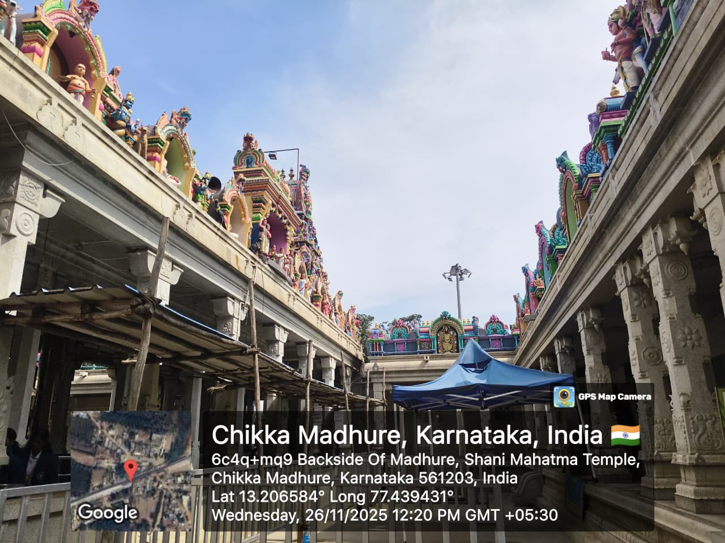
  - Vehicle Pooja Bay: Due to the high demand for vehicle blessings, there is a dedicated, paved area within the complex specifically designed for cars and bikes to be parked and blessed without obstructing pedestrian traffic.

Figure2.4: Madure temple architecture

Chikka Madhure Temple: Today
Today, is a great day to visit the Sri Shanimahathma Temple in Chikka Madhure if you are looking for a relatively peaceful experience compared to the heavy rush of Saturdays.
Here is the essential information for a visit today:
1. Timings and Rituals
- Operating Hours: The temple is open from 6:00 AM to 8:00 PM.
- Maha Pooja: The grand final pooja of the day, known as Maha Pooja, is performed at 8:00 PM every evening.
- Sunday Crowd: Unlike Saturdays, which see massive crowds due to the special significance of Saturn (Shani), Sundays are generally more manageable. However, since it is a weekend, you may still see families and travellers visiting for a day trip.
2. Offerings and Sevas
- Ellu Batti (Sesame Offering): You can perform the signature ritual of lighting Ellu Batti (black sesame seeds tied in cloth and soaked in oil) in the designated fireplace. This ritual is believed to reduce the ill effects of Sade Sathi.
- Vahana Pooja: If you have a new vehicle, today is a good time to get a Vahana Pooja done. There is a dedicated area for this, and the priests will perform the ritual to bless your new car or bike.
- Anna Dasoha (Free Meals): The temple serves free lunch to all devotees at the Dasoha Bhavan. This typically starts around 12:00 PM and continues until 4:00 PM. The food is known to be delicious and is served with great hospitality.
3. Visiting Tips for Today
- Weather & Setting: With the current December weather in Bengaluru, the lakeside location of the temple (next to Madhure Kere) will be very pleasant, especially in the late afternoon.
- Parking: There is ample parking inside the temple complex. However, be cautious of local touts and stick to the official temple parking fees.
- Laddus: If you want to take back some prasadam, the temple's Laddus are highly recommended and are sold at the counter for approximately ₹40 each.
4. How to Get There
- Route: It is about 45 km from Bengaluru. The best route is to drive toward Nelamangala and then take the road toward Doddaballapur.
- Public Transport: You can take a KSRTC or private bus from Majestic/Bengaluru to Nelamangala, and from there, local buses or shared autos frequently go toward Chikka Madhure.

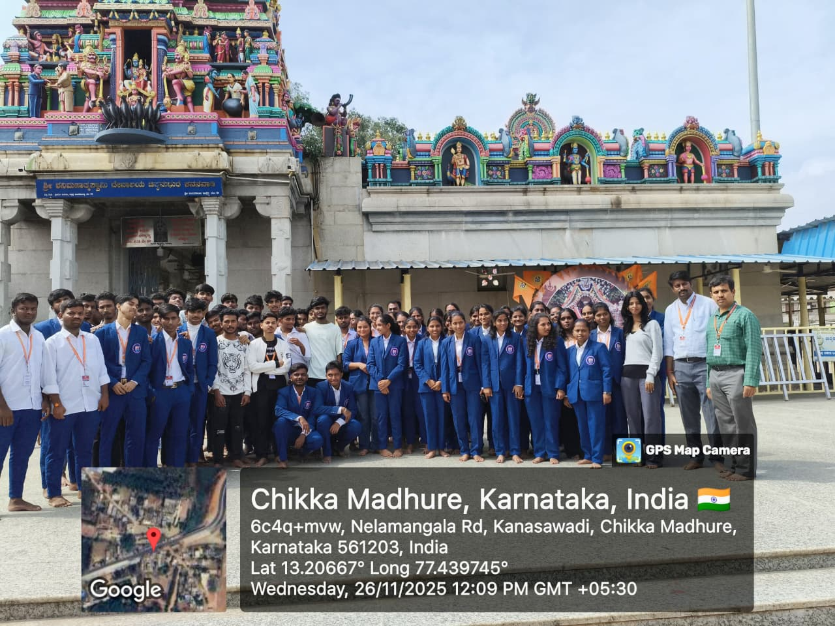
Figure2.5: Chikka Madhure temple

2.7 Conclusion
Bengaluru’s heritage walk and crafts corner offer a fascinating insight into the city’s historical and cultural legacy. The Sri Shanimahathma Temple in Chikka Madhure serves as a profound spiritual sanctuary that transcends its humble beginnings as a small village shrine. It has evolved into a significant cultural landmark for the people of Karnataka, offering a unique blend of traditional Dravidian architecture and a serene lakeside atmosphere. Whether devotees are seeking astrological relief through the symbolic lighting of sesame wicks or simply visiting for the community spirit of the Anna Dasoha (free meals), the temple provides a powerful sense of solace and belonging. Its legacy, rooted in the faith of a local farmer rather than royal decree, ensures that it remains an accessible and deeply personal destination for those looking to navigate life's challenges with divine guidance and inner peace.

SOCIAL CONNECT AND RESPONSIBILITY

ADITYA COLLEGE OF ENGINEERING AND TECHNOLOGY

Affiliated Visvesvaraya Technological University (VTU) Approved by AICTE New Delhi Kamakshipura,
Hesarghatta Main Road Rajankunte, Yelahanka, Bengaluru -560089

Group: Siddalingayya, Venkatesh Kumar, Vaibhav, Basavaraj, Vinay S S
Student Name: Venkatesh Kumar
USN: 1DI24CS086
Module No.: 03
Tittle: ORGANIC FARMING
Name of the course coordinator: Prof. Charan

Date | Time | Main point of the day
26-11-25 | 2.30 pm  To  4.00 pm | 1. Visited organic farm  to learn about benefits of  organic farming.  2. Knowing the cultivation  process.

Dept Of CSE

  - Introduction

Module 3

ORGANIC FARMING

Organic farming, also known as ecological farming or biological farming, is an agricultural system that uses fertilizers of organic origin such as compost manure, green manure, and bone meal and places emphasis on techniques such as crop rotation and companion planting. It originated early in the 20th century in reaction to rapidly changing farming practices. Certified organic agriculture accounts for 70 million hectares (170 million acres) globally, with over half of that total in Australia. Organic farming continues to be developed by various organizations today. Biological pest control, mixed cropping and the fostering of insect predators are encouraged. Organic standards are designed to allow the use of naturally occurring substances while prohibiting or strictly limiting synthetic substances. Organic farming can be beneficial on biodiversity and environmental protection at local level. However, because organic farming has lower yields compared to conventional farming, additional agricultural land is needed elsewhere in the world, which means that natural land has to be converted into agricultural land. This can cause loss of biodiversity and negative climate effects that outweigh the local environmental gains achieved.
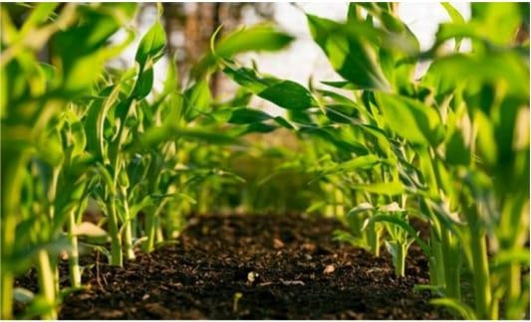
Figure3.1: Organic farming

History
The concepts of organic agriculture were developed in the early 1900s by Sir Albert Howard,
F.H. King, Rudolf Steiner, and others who believed that the use of animal manures (often made into compost), cover crops, crop rotation, and biologically based pest controls resulted in a better farming system. Howard, having worked in India as an agricultural researcher, gained much inspiration from the traditional and sustainable farming practices he encountered there and advocated for their adoption in the West. Such practices were further promoted by various advocates such as J.I. Rodale and his son Robert, in the 1940s and onward, who published Organic Gardening and Farming magazine and a number of texts on organic farming. The demand for organic food was stimulated in the 1960s by the publication of Silent Spring, by Rachel Carson, which documented the extent of environmental damage caused by insecticides.

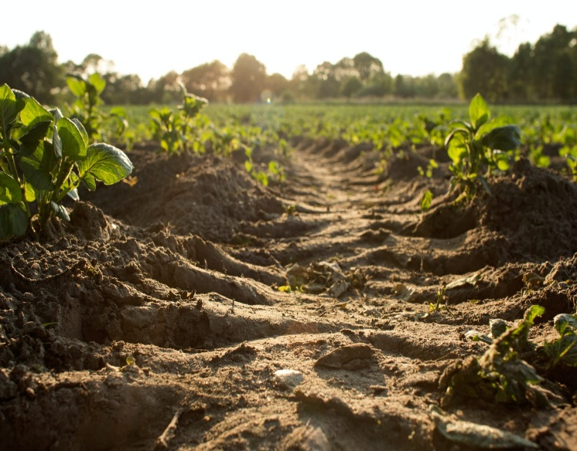
Figure3.2: Organic farming

Terminology
The use of "organic" popularized by Howard and Rodale refers more narrowly to the use of organic matter derived from plant compost and animal manures to improve the humus content of soils, grounded in the work of early soil scientists who developed what was then called "humus farming". Since the early 1940s the two camps have tended to merge. Biodynamic agriculturists, on the other hand, used the term "organic" to indicate that a farm should be viewed as a living organism, in the sense of the following quotation: "An organic farm, properly speaking, is not one that uses certain methods and substances and avoids others; it is a farm whose structure is formed in imitation of the structure of a natural system that has the integrity, the independence and the benign dependence of an organism".


Figure3.3: Red Soil

Methods
Organic farming methods combine scientific knowledge of ecology and some modern technology with traditional farming practices based on naturally occurring biological processes. Organic farming methods are studied in the field of eco- ecology. While conventional agriculture uses synthetic pesticides and water-soluble synthetically purified fertilizers, organic farmers are restricted by regulations to using natural pesticides and fertilizers.
The principal methods of organic farming include crop rotation, green manures and compost, biological pest control, and mechanical cultivation. These measures use the natural environment to enhance agricultural productivity: legumes are planted to fix nitrogen into the soil, natural insect predators are encouraged, crops are rotated to confuse pests and renew soil, and natural materials such as potassium bicarbonate and mulches are used to control disease and weeds. Genetically modified seeds and animals are excluded.
While organic is fundamentally different from conventional because of the use of carbon-based fertilizers compared with highly soluble synthetic based fertilizers and biological pest control instead of synthetic pesticides, organic farming and largescale conventional farming are not entirely mutually exclusive. Many of the methods developed for organic agriculture have been borrowed by more conventional agriculture. For example, Integrated Pest Management is a multifaceted strategy that uses various organic methods of pest control whenever possible, but in conventional farming could include synthetic pesticides only as a last resort.

Soil Management
Organic farming relies more heavily on the natural breakdown of organic matter than the average conventional farm, using techniques like green manure and composting, to replace nutrients taken from the soil by previous crops. Farmers use a variety of methods to improve soil fertility, including crop rotation, cover cropping, reduced tillage, and application of compost. By reducing fuel-intensive tillage, less soil organic matter is lost to the atmosphere. This has an added benefit of carbon sequestration, which reduces greenhouse gases and helps reverse climate change. Reducing tillage may also improve soil structure and reduce the potential for soil erosion.
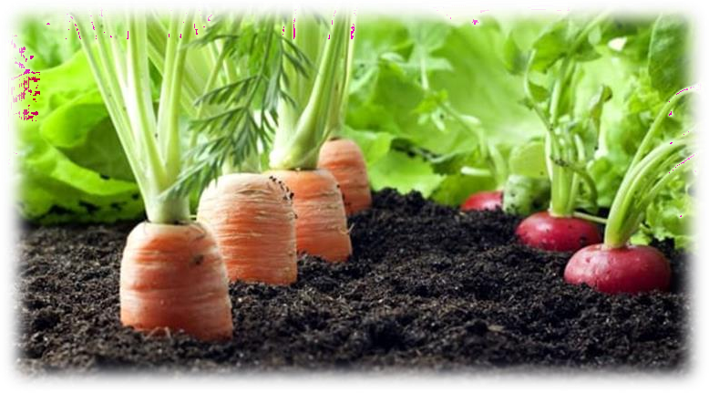

Figure3.4: Soil Management

Differences between Organic and Conventional Farming

Methods

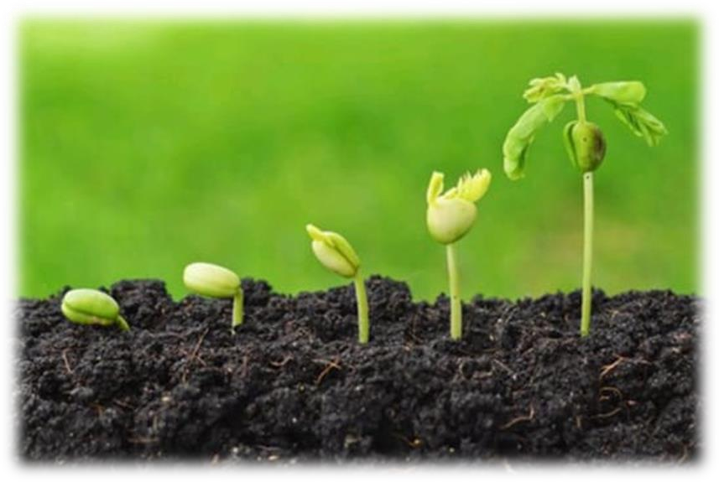
Figure3.5: Block soil

Reasons for Organic Farming
The population of the planet is skyrocketing and providing food for the world is becoming extremely difficult. The need of the hour is sustainable cultivation and production of food for all.
The Green Revolution and its chemical-based technology are losing its appeal as dividends are falling and returns are unsustainable. Pollution and climate change are other negative externalities caused by the use of fossil fuel- based chemicals.
In-spite of our diet choices, organic food is the best choice you’ll ever make, and this means embracing organic farming methods. Here are the reasons why we need to take up organic farming methods:

To Accrue the Benefits of Nutrients
Foods from organic farms are loaded with nutrients such as vitamins, enzymes, minerals and other micro-nutrients compared to those from conventional farms. This is because organic farms are managed and nourished using sustainable practices. In fact, some past researchers

collected and tested vegetables, fruits, and grains from both organic farms and conventional farms. The conclusion was that food items from organic farms had way more nutrients than those sourced from commercial or conventional farms. The study went further to substantiate that- five servings of these fruits and vegetables from organic farms offered sufficient allowance of vitamin C. However, the same quantity of fruits and vegetables did not offer the same sufficient allowance.

Stay Away From- GMOs
Statistics show that genetically modified foods (GMOs) are contaminating natural foods sources at real scary pace, manifesting grave effects beyond our comprehension. What makes them a great threat is they are not even label. So, sticking to organic foods sourced from veritable sources is the only way to mitigate these grave effects of GMOs.

Natural and Better
Taste Those that have tasted organically farmed foods would attest to the fact that they have a natural and better taste. The natural and superior taste stems from the well balanced and nourished soil. Organic farmers always prioritize quality over quantity.

Direct Support to Farming
Purchasing food items from organic farmers is a surefire investment in a cost -effective future. Conventional farming methods have enjoyed great subsidies and tax cuts from most governments over the past years. This has led to the proliferation of commercially produced foods that have increased dangerous diseases like cancer. It’s time governments invested in organic farming technologies to mitigates these problems and secure the future. It all starts with you buying food items from known organic sources.

To Conserve Agricultural Diversity
These days, it normal to hear news about extinct species and this should be a major concern. In the last century alone, it is approximated that 75 percent of the agricultural diversity of crops has been wiped out. Slanting towards one form of farming is a recipe for disaster in the future. A classic example is a potato. There were different varieties available in the marketplace. Today, only one species of potato -dominate. This is a dangerous situation because if pests knock out the remaining potato specie available today, we will not have potatoes anymore. This is why we need organic farming methods that produce disease and pest-resistant crops to guarantee a sustainable future.

To Prevent Antibiotics, Drugs, and Hormones in Animal Products
Commercial dairy and meat are highly susceptible to contamination by dangerous substances. A statistic in an American journal revealed that over 90% of chemicals the population consumes emanate from meat tissue and dairy products. According to a report by Environmental Protection Agency (EPA), a vast majority of pesticides are consumed by the population stem from poultry, meat, eggs, fish and dairy product since animals and birds that produce these products sit on top of the food chain.

This means they are fed foods loaded with chemicals and toxins. Drugs, antibiotics, and growth hormones are also injected into these animals and so, are directly transferred to meat and dairy products. Hormone supplementation fed to farmed fish, beef and dairy products contributes mightily to the ingestion of chemicals. These chemicals only come with a lot of complications like genetic problems, cancer risks, growth of tumor and other complications.
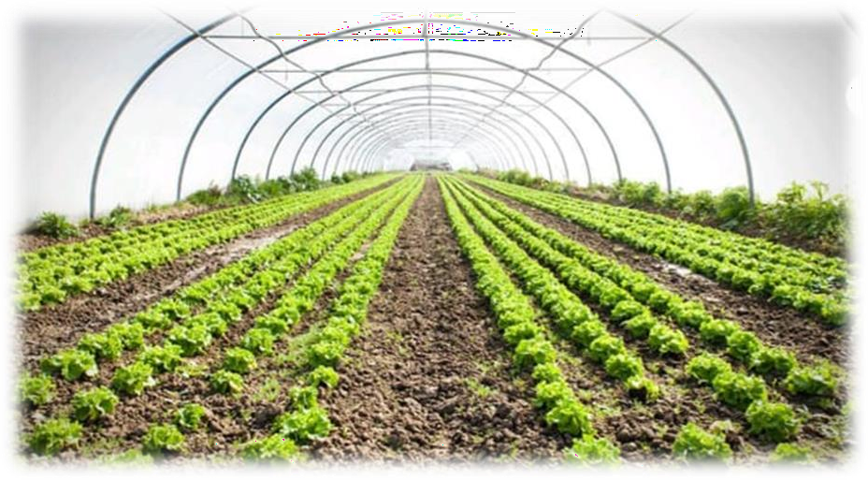
Figure3.6: Organic farm

Advantages of Organic Farming
- Better Nutrition As compared to a longer time conventionally grown food, organic food is much richer in nutrients. The nutritional value of a food item is determined by its mineral and vitamin content. Organic farming enhances the nutrients of the soil which is passed on to the plants and animals.
- Helps us Stay Healthy Organic foods do not contain any chemicals. This is because organic farmers don’t use chemicals at any stage of the food-growing process like their commercial counterparts. Organic farmers use natural farming techniques that don’t harm humans and the environment. These foods keep dangerous diseases like cancer and diabetes at bay.
- Free of Poison Organic farming does not make use of poisonous chemicals, pesticides and weedicides. Studies reveal that a large section of the population fed on toxic substances used in conventional agriculture have fallen prey to diseases like cancer. As organic farming avoids these toxins, it reduces the sickness and diseases due to them.
- Organic Foods Are Highly Authenticated For any product to qualify as organic food; it must undergo quality checks and the creation process rigorously investigated. The same rule applies to international markets. This is a great victory for consumers because they are getting real organic foods. These quality checks and investigations weed out quacks who want to benefit from the organic food label by delivering commercially produced foods instead.
- Lower Prices There is a big misconception that organic foods are relatively expensive. The truth is they are actually cheaper because they don’t require the application of expensive pesticides, insecticides, and weedicides. In fact, you can get organic foods direct from the source at really reasonable prices.

- Enhanced Taste The quality of food is also determined by its taste. Organic food often tastes better than other food. The sugar content in organically grown fruits and vegetables provides them with extra taste. The quality of fruits and vegetables can be measured using Brix analysis.
- Organic Farming Methods are Eco-friendly In commercial farms, the chemicals applied to infiltrate into the soil and severely contaminate it and nearby water sources. Plant life, animals, and humans are all impacted by this phenomenon. Organic farming does not utilize these harsh chemicals so; the environment remains protected.
- Longer Shelf–life Organic plants have greater metabolic and structural integrity in their cellular structure than conventional crops. This enables the storage of organic food for a longer time.
Organic farming is preferred as it battles pests and weeds in a non-toxic manner, involves fewer input costs for cultivation and preserves the ecological balance while promoting biological diversity and protection of the environment.

Disadvantages of Organic Farming
    - Incompetent: The major issue of organic farming is the lack of inadequate infrastructure and marketing of the product.
    - Less production: The products obtained through organic farming are less in the initial years as compared to that in chemical products. So, farmers find it difficult to accommodate large- scale production.
    - Shorter shelf life: Organic products have more flaws and a shorter shelf life than that of chemical products.
    - Limited production: Off-season crops are limited and have fewer options in organic farming.
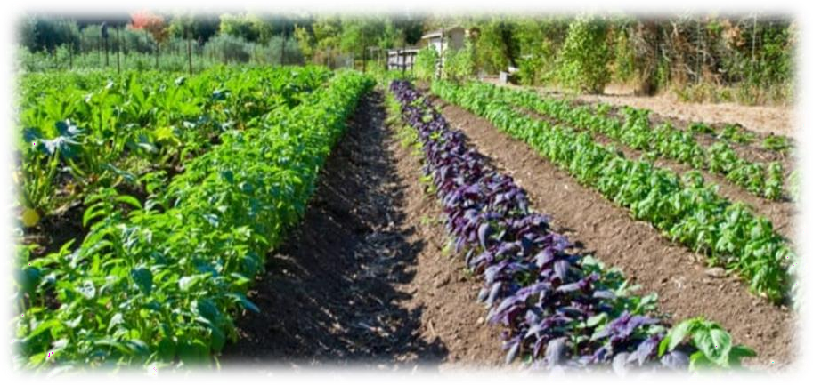
Figure3.7: Shrubs and Herbs

Waste Management
Waste management or waste disposal includes the processes and actions required to manage waste from its inception to its final disposal. This includes the collection, transport, treatment

and disposal of waste, together with monitoring and regulation of the waste management process and waste-related laws, technologies, economic mechanisms.
Waste can be solid, liquid, or gases and each type has different methods of disposal and management. Waste management deals with all types of waste, including industrial, biological, household, municipal, organic, biomedical, radioactive wastes. In some cases, waste can pose a threat to human health. Health issues are associated throughout the entire process of waste management. Health issues can also arise indirectly or directly: directly through the handling of solid waste, and indirectly through the consumption of water, soil and food. Waste is produced by human activity, for example, the extraction and processing of raw materials. Waste management is intended to reduce adverse effects of waste on human health, the environment, planetary resources and aesthetics.
The aim of waste management is to reduce the dangerous effects of such waste on the environment and human health. A big part of waste management deals with municipal solid waste, which is created by industrial, commercial, and household activity.
Waste management practices are not uniform among countries (developed and developing nations); regions (urban and rural areas), and residential and industrial sectors can all take different approaches. Proper management of waste is important for building sustainable and livable cities, but it remains a challenge for many developing countries and cities. A report found that effective waste management is relatively expensive, usually comprising 20%–50% of municipal budgets. Operating this essential municipal service requires integrated systems that are efficient, sustainable, and socially supported. A large portion of waste management practices deal with municipal solid waste (MSW) which is the bulk of the waste that is created by household, industrial, and commercial activity. According to the Intergovernmental Panel on Climate Change (IPCC), municipal solid waste is expected to reach approximately 3.4 Gt by 2050; however, policies and lawmaking can reduce the amount of waste produced in different areas and cities of the world. Measures of waste management include measures for integrated techno-economic mechanisms of a circular economy, effective disposal facilities, export and import control and optimal sustainable design of products that are produced.
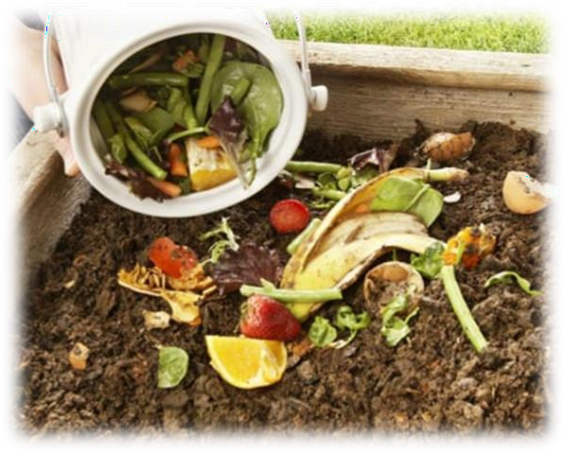
Figure3.8: Wet waste Management

Waste Hierarchy
The waste hierarchy refers to the "3 Rs" Reduce, Reuse and Recycle, which classifies waste management strategies according to their desirability in terms of waste minimization. The waste hierarchy is the bedrock of most waste minimization strategies. The waste hierarchy is represented as a pyramid because the basic premise is that policies should promote measures to prevent the generation of waste. The next step or preferred action is to seek alternative uses for the waste that has been generated, i.e., by re-use. The next is recycling which includes composting.

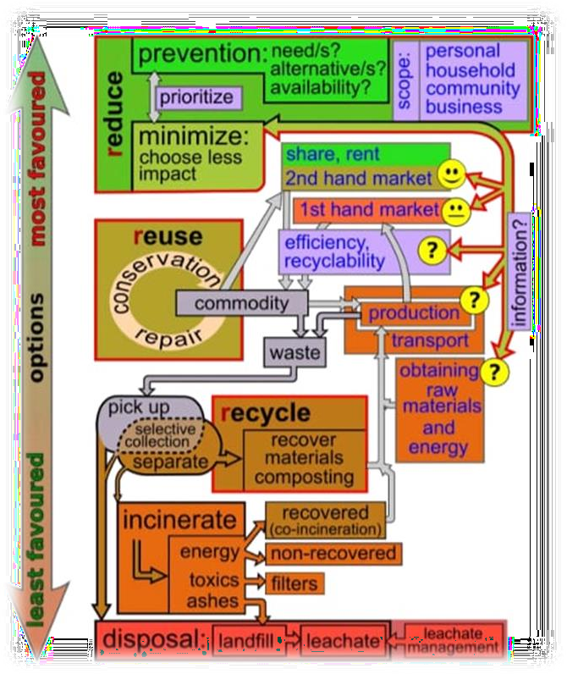
Figure3.9: Waste Hierarchy
Recoverable materials that are organic in nature, such as plant material, food scraps, and paper products, can be recovered through composting and digestion processes to decompose the organic matter. The resulting organic material is then recycled as mulch or compost for agricultural or landscaping purposes. There are different types of composting and digestion methods and technologies. They vary in complexity from simple home compost heaps to large scale industrial digestion of mixed domestic waste. The different methods of biological decomposition are classified as aerobic or anaerobic methods. Some methods use the hybrids of these two methods. The anaerobic digestion of the organic fraction of solid waste is more environmentally effective than landfill, or incineration. The intention of biological processing in waste management is to control and accelerate the natural process of decomposition of organic matter.

Energy Recovery
Energy recovery from waste is the conversion of non-recyclable waste materials into usable heat, electricity, or fuel through a variety of processes, including combustion, gasification, anaerobic digestion, and landfill gas recover. This process is often called waste-to-energy. Energy recovery from waste is part of the non- hazardous waste management hierarchy. Using energy recovery to convert nonrecyclable waste materials into electricity and heat, generates a renewable energy source and can reduce carbon emissions by offsetting the need for energy from fossil sources as well as reduce methane generation from landfills. Globally, waste-to energy accounts for 16% of waste management
The energy content of waste products can be harnessed directly by using them as a direct combustion fuel, or indirectly by processing them into another type of fuel. Pyrolysis and gasification are two related forms of thermal treatment where waste materials are heated to high temperatures with limited oxygen availability. The process usually occurs in a sealed vessel under high pressure. The solid residue (char) can be further refined into products such as activated carbon. Gasification and advanced Plasma arc gasification are used to convert organic materials directly into a synthetic gas (syngas) composed of carbon monoxide and hydrogen.
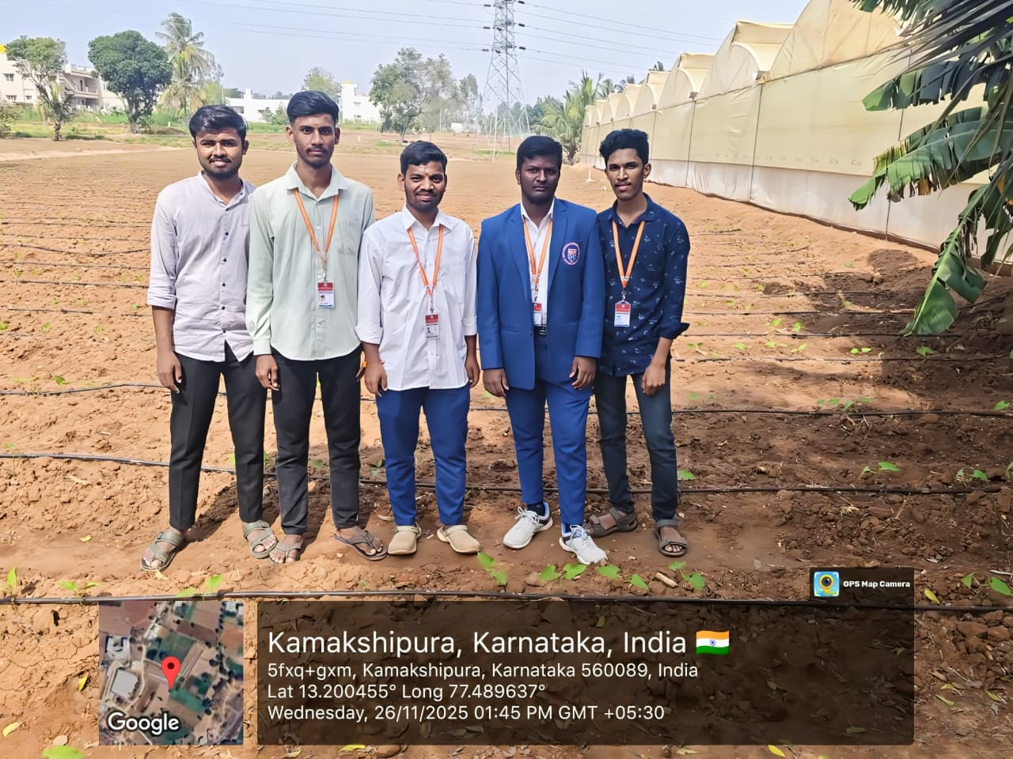
Fig 3.10: Organic forming

Conclusion
Organic and organic agriculture are terms that almost everyone has heard of these days. Organic farming is an agricultural method that adheres to the principles of sustainable development. It’s an agricultural production management method that does not utilize pesticides, chemical fertilizers, industrial synthetic products, or genetically modified organisms. Organic agriculture contributes to long-term development in society (health, employment, etc.), the environment (methane emissions, water resources, etc.), and the economy (source of wealth, etc.). To promote the adoption of more organic and other novel farming systems, incentives for suitable

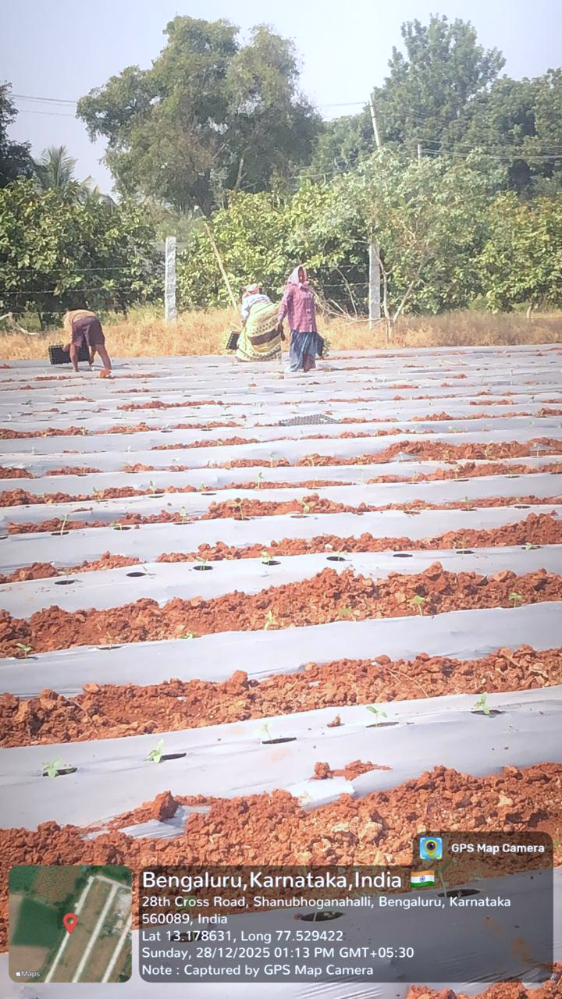
markets, reform of farm-related laws, and reorientation of public supported agricultural science are required. Lower yields are less of a concern if society learns to value the other three characteristics of organic and other creative agricultural systems: improved economic, social, environmental-sustainability.

Figure3.11: Organic Forming.

SOCIAL CONNECT AND RESPONSIBILITY

ADITYA COLLEGE OF ENGINEERING AND TECHNOLOGY

Affiliated Visvesvaraya Technological University (VTU) Approved by AICTE New Delhi Kamakshipura,
Hesarghatta Main Road Rajankunte, Yelahanka, Bengaluru -560089

Group: Siddalingayya, Venkatesh Kumar, Vaibhav, Basavaraj, Vinay S S
Student Name: Vaibhav
USN: 1DI24CS083
Module No.: 04
Tittle: WATER CONSERVATION
Name of the course coordinator: Prof. Charan

Date | Time | Main point of the day
26-11-25 | 1.00 pm  To  5.00 pm | 1. Creating awareness for  the need to conserve  water among the people in  nearby locality.  2. Knowing the importance of  water bodies.

Dept Of CSE

Module 4

WATER CONSERVATION

Introduction
Water is one of the basic necessities for every living being and we cannot imagine a life without water. It is the natural resource and the main constituent of our planet earth. Water is the universal solvent and plays a key role in the existence of various forms of life on the planet earth. It is widely used for various purposes such as washing, bathing, cleaning, cooking, drinking, and other industrial and domestic uses. Water is a colorless and odorless substance that is essential for the survival of living beings. There are various sources of water such as wells, rivers, ponds, lakes, oceans, big dams, and streams. As we all know, nearly 70 to 80 percent of the Earth’s surface is covered by water, among which only 1-2 per cent water is pure and suitable for human use.
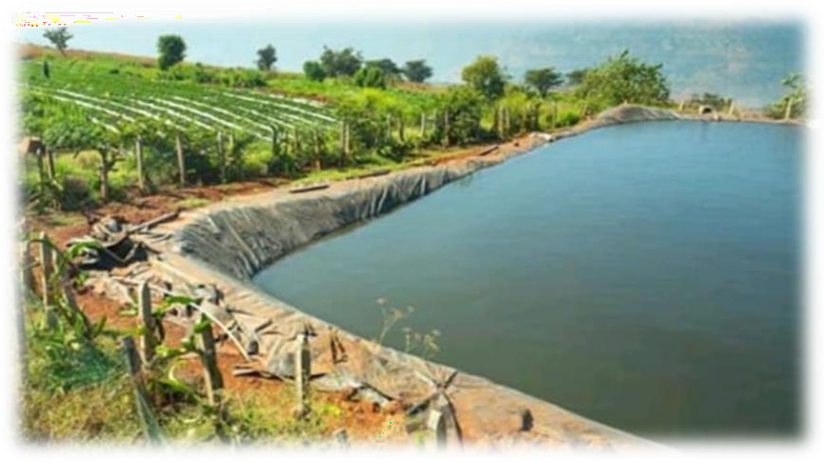
Figure4.1: Water reservoir

Conservation of Water
Conservation of water mainly refers to protect, preserve, and control the usage of water and its resources. It is the system introduced to manage freshwater, reduce the wastage and protect the water and its resources in order to reduce and to avoid the scarcity. Therefore, we all should come forward to create awareness about conservation of water among our own friends, family, neighbours, society, etc. Conservation of water is very much essential as it saves life on earth.
Water conservation includes all the policies, strategies and activities to sustainably manage the natural resource of fresh water, to protect the hydrosphere, and to meet the current and future human demand (thus avoiding water scarcity). Population, household size and growth and affluence all affect how much water is used. Factors such as climate change have increased pressures on natural water resources especially in manufacturing and agricultural irrigation.

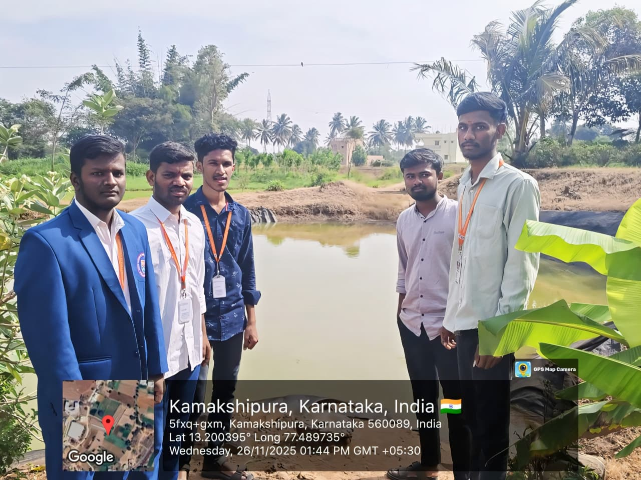
Fig 4.2: Conservation of Water
Many countries have already implemented policies aimed at water conservation, with much success. The key activities to conserve water are as follows: any beneficial reduction in water loss, use and waste of resources, avoiding any damage to water quality; and improving water management practices that reduce the use or enhance the beneficial use of water. Technology solutions exist for households, commercial and agricultural applications. Water conservation programs involved in social solutions are typically initiated at the local level, by either municipal water utilities or regional governments. Common strategies include public outreach campaigns, tiered water rates (charging progressively higher prices as water use increases), or restrictions on outdoor water use such as lawn watering and car washing.

Aim of Water Conservation
The Aims of water conservation efforts include:
    - Ensuring the availability of water for future generations where the withdrawal of fresh water from an ecosystem does not exceed its natural replacement rate.
    - Energy conservation as water pumping, delivery, and wastewater treatment facilities consume a significant amount of energy. In some regions of the world, over 15% of the total electricity consumption is devoted to water management.
    - Habitat conservation where minimizing human water usage helps to preserve freshwater habitats for local wildlife and migrating water fowl, but also water quality.

Rainwater Harvesting
Rainwater harvesting (RWH) is the collection and storage of rain, rather than allowing it to run off. Rainwater is collected from a roof-like surface and redirected to a tank, cistern, deep pit

(well, shaft, or borehole), aquifer, or a reservoir with percolation, so that it seeps down and restores the ground water. Dew and fog can also be collected with nets or other tools. Rainwater harvesting differs from storm water harvesting as the runoff is typically collected from roofs and other surfaces for storage and subsequent reuse. Its uses include watering gardens, livestock, irrigation, domestic use with proper treatment, and domestic heating. The harvested water can also be committed to longer-term storage or groundwater recharge.
Rainwater harvesting is one of the simplest and oldest methods of self-supply of water for households, having been used in South Asia and other countries for many thousands of years. Installations can be designed for different scales including households, neighborhoods and communities and can also be designed to serve institutions such as schools, hospitals and other public facilities Rainwater harvesting provides the independent water supply during regional water restrictions, and in developed countries, it is often used to supplement the main supply. It provides water when a drought occurs, can help mitigate flooding of lovely areas, and reduces demand on wells which may enable groundwater levels to be sustained.
Rainwater harvesting increases the availability of water during dry seasons by increasing the levels of dried bore wells and wells. Surface water supply is readily available for various purposes thus reducing dependence on underground water.
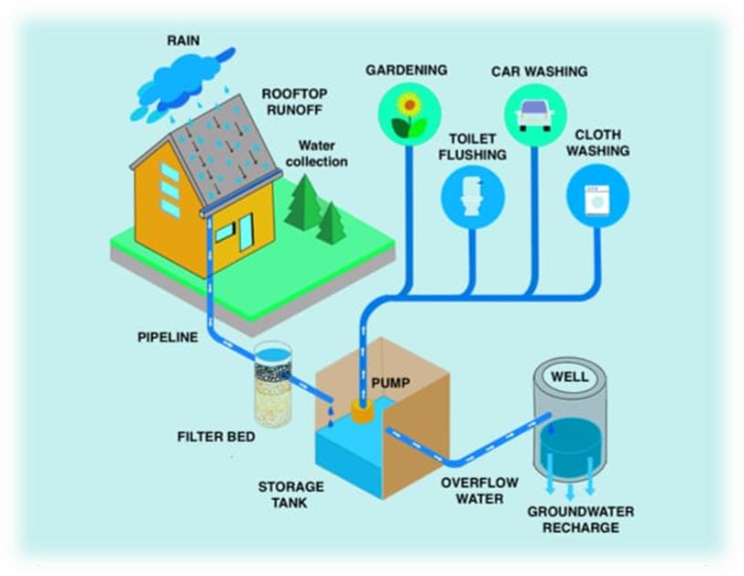
Figure4.3: Rainwater Harvesting
It improves the quality of ground by diluting salinity. It does not cause pollution and is environmentally friendly. It is cost-effective and easily affordable. It also helps in the availability of potable water, as rainwater is substantially free of salinity and other salts. Applications of rainwater harvesting in urban water system provides a substantial benefit for both water supply and wastewater subsystems by reducing the need for clean water in water distribution systems, less generated storm water in sewer systems, and a reduction in storm water runoff polluting freshwater bodies.

A large body of work has focused on the development of life cycle assessment and its costing methodologies to assess the level of environmental impacts and money that can be saved by implementing rainwater harvesting systems.

Irrigation
Irrigation (also referred to as watering) is the practice of applying controlled amounts of water to land to help grow crops, landscape plants, and lawns. Irrigation has been a key aspect of agriculture for over 5,000 years and has been developed by many cultures around the world. Irrigation helps to grow crops, maintain landscapes, and revegetate disturbed soils in dry areas and during times of below average rainfall. In addition to these uses, irrigation is also employed to protect crops from frost, suppress weed growth in grain fields, and prevent soil consolidation. It is also used to cool livestock, reduce dust, dispose of sewage, and support mining operations. Drainage, which involves the removal of surface and sub-surface water from a given location, is often studied in conjunction with irrigation.
There are several methods of irrigation that differ in how water is supplied to plants. Surface irrigation, also known as gravity irrigation, is the oldest form of irrigation and has been in use for thousands of years. In sprinkler irrigation, water is piped to one or more central locations within the field and distributed by overhead high -pressure water devices. Micro-irrigation is a system that distributes water under low pressure through a piped network and applies it as a small discharge to each plant. Micro-irrigation uses less pressure and water flow than sprinkler irrigation. Drip irrigation delivers water directly to the rootzone of plants. Sub irrigation has been used in field crops in areas with high water tables for many years. It involves artificially raising the water table to moisten the soil below the rootzone of plants.
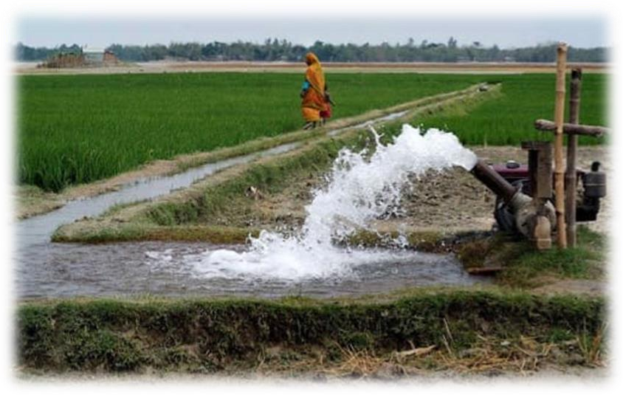
Figure4.4: Irrigation
Irrigation water can come from groundwater (extracted from springs or by using wells), from surface water (withdrawn from rivers, lakes or reservoirs) or from nonconventional sources like treated wastewater, desalinated water, drainage water, or fog collection. Irrigation can be supplementary to rainfall, which is common in many parts of the world as rain fed agriculture,

or it can be full irrigation, where crops rarely rely on any contribution from rainfall. Full irrigation is less common and only occurs in arid landscapes with very low rainfall or when crops are grown in semi-arid areas outside of rainy seasons.

Types of Irrigation
- Surface Irrigation
- Localized Irrigation
- Sprinkler Irrigation
- Drip Irrigation
- Centre Pivot Irrigation
- Sub Irrigation
- Manual Irrigation
The environmental effects of irrigation relate to the changes in quantity and quality of soil and water as a result of irrigation and the subsequent effects on natural and social conditions in river basins and downstream of an irrigation scheme. The effects stem from the altered hydrological conditions caused by the installation and operation of the irrigation scheme. Amongst some of these problems is depletion of underground aquifers through over drafting.
Soil can be over-irrigated due to poor distribution uniformity or management wastes water, chemicals, and may lead to water pollution. Over-irrigation can cause deep drainage from rising water tables that can lead to problems of irrigation salinity requiring water table control by some form of subsurface land drainage.

Protecting Groundwater Resources.
Groundwater is the water present beneath Earth's surface in rock and soil pore spaces and in the fractures of rock formations. About 30 percent of all readily available freshwater in the world is groundwater. A unit of rock or an unconsolidated deposit is called an aquifer when it can yield a usable quantity of water. The depth at which soil pore spaces or fractures and voids in rock become completely saturated with water is called the water table. Groundwater is recharged from the surface; it may discharge from the surface naturally at springs and seeps, and can form oases or wetlands. Groundwater is also often withdrawn for agricultural, municipal, and industrial use by constructing and operating extraction wells. The study of the distribution and movement of groundwater is hydrogeology, also called groundwater hydrology.
Typically, groundwater is thought of as water flowing through shallow aquifers, but, in the technical sense, it can also contain soil moisture, permafrost (frozen soil), immobile water in very low permeability bedrock, and deep geothermal or oil formation water. Groundwater is hypothesized to provide lubrication that can possibly influence the movement of faults. It is likely that much of Earth's subsurface contain some water, which may be mixed with other

fluids in some instances. Groundwater is often cheaper, more convenient and less vulnerable to pollution than surface water. Therefore, it is commonly used for public water supplies.

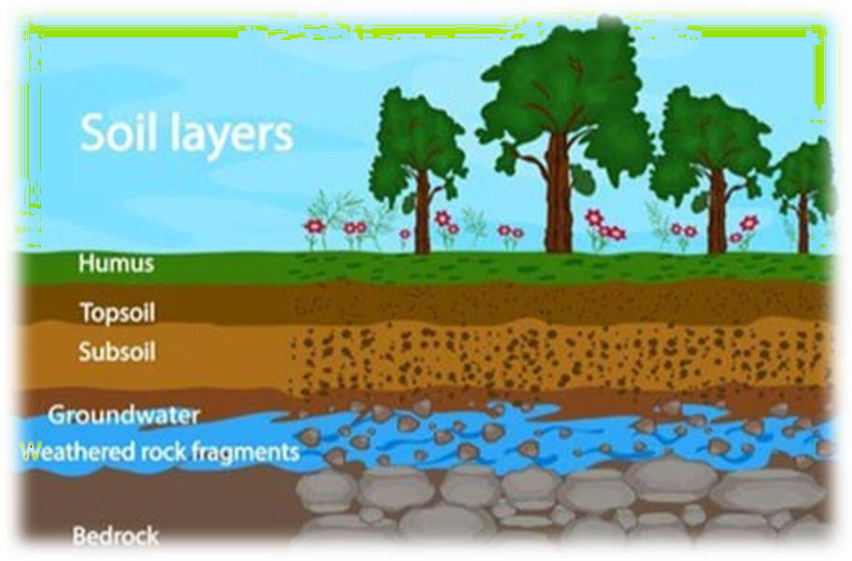
Figure4.5: Ground Water

Water-saving technology for the home:
    - Faucet aerators, which break water flow into fine droplets to maintain "wetting effectiveness" while using less water.
    - An additional benefit is that they reduce splashing while washing hands and dishes
    - Wastewater reuse or recycling systems, allowing:
    - Reuse of grey water for flushing toilets or watering gardens
    - Recycling of wastewater through purification at a water treatment plant.
    - High-efficiency clothes washers
    - Weather-based irrigation controllers
    - Garden hose nozzles that shut off the water when it is not being used, instead of letting a hose run.
    - Low flow taps in wash basins
    - Swimming pool covers that reduce evaporation and can warm pool water to reduce water, energy and chemical costs.

Agricultural Applications
Water is a very important part in irrigation. Plants always take a lot of ground water thus ground water should be replenished. For crop irrigation, optimal water efficiency means minimizing

losses due to evaporation, runoff or subsurface drainage while maximizing production. An evaporation pan in combination with specific crop correction factors can be used to determine how much water is needed to satisfy plant requirements. Flood irrigation, the oldest and most common type, is often very uneven in distribution, as parts of a field may receive excess water in order to deliver sufficient quantities to other parts. Overhead irrigation, using center-pivot or lateral-moving sprinklers, has the potential for a much more equal and controlled distribution pattern. Drip irrigation is the most expensive and least-used type, but offers the ability to deliver water to plant roots with minimal losses. However, drip irrigation is increasingly affordable, especially for the home gardener and in light of rising water rates. Using drip irrigation methods can save up to 30,000 gallons of water per year when replacing irrigation systems that spray in all directions. There are also cheap effective methods similar to drip irrigation such as the use of soaking hoses that can even be submerged in the growing medium to eliminate evaporation.
As changing irrigation systems can be a costly undertaking, conservation efforts often concentrate on maximizing the efficiency of the existing system. This may include chiseling compacted soils, creating furrow dikes to prevent runoff, and using soil moisture and rainfall sensors to optimize irrigation schedules. Usually, large gains in efficiency are possible through measurement and more effective management of the existing irrigation system.
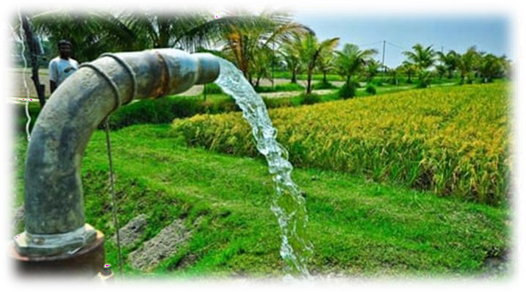
Figure4.6: Agricultural pump

Water Reuse
Water shortage has become an increasingly difficult problem to manage. More than 40% of the world's population live in a region where the demand for water exceeds its supply. The imbalance between supply and demand, along with persisting issues such as climate change and population growth, has made water reuse a necessary method for conserving water. There are a variety of methods used in the treatment of waste water to ensure that it is safe to use for irrigation of food crops and/or drinking water.
Seawater desalination requires more energy than the desalination of fresh water. Despite this, many seawater desalination plants have been built in response to water shortages around the world. This makes it necessary to evaluate the impacts of seawater desalination and to find was to improve desalination technology.

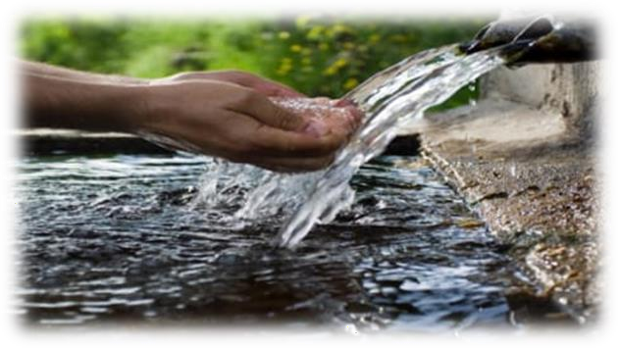
Figure4.7: Water Reuse
Sand filtration is another method used to treat water. Recent studies show that sand filtration needs further improvements, but it is approaching optimization with its effectiveness at removing pathogens from water. Sand filtration is very effective at removing protozoa and bacteria, but struggles with removing viruses. Large-scale sand filtration facilities also require large surface areas to accommodate them.
The removal of pathogens from recycled water is of high priority because wastewater always contains pathogens capable of infecting humans. The levels of pathogenic viruses have to be reduced to a certain level in order for recycled water to not pose a threat to human populations. Further research is necessary to determine more accurate methods of assessing the level of pathogenic viruses in treated wastewater.

The Need for Water Conservation
Conserving water helps us by supplying more amount of water for longer usage. It has become necessary in all areas because these natural resources are reducing along with the increasing population and their usages.

Several techniques can be implemented for the conservation of water that has been discussed below:
    - Careful Use of Water: Keep the taps turned off when not in use. Usage of efficient home appliances like washing machines and dishwashers can save a lot of water. Even without the appliances, make sure you don’t overuse water while washing dishes or clothes.
    - Don’t Run the Faucet to Clean Vegetables: Fill a container with runs down will lead to unnecessary wastage of water.
    - Check for Leaks: Leaks can cause a significant amount of water loss if left unchecked. So, check the faucet, taps, and pipes for leaks regularly. While turning the tap off make sure to turn it all the way or it may keep dripping.
    - Water the Plants Smartly: While watering your plants keep in mind the temperature and time of the day, so water doesn’t evaporate quickly. Reuse water from cleaning and laundry to water the plawater to wash fruits and vegetables. Keeping them under the faucet while water plants.
    - The best way to conserve water is to recycle and reuse it.

    - Try limiting your shower time to 10 to 15 minutes because humans carelessly consume gallons of water for luxuriously long showers. So, Reducing the shower time would prevent excessive wastage of water.
    - Try using a compost Bin instead of in-sink garbage disposal. Compost bins are environmentally friendly and reduce water wastage.
    - Maintenance of appliances can prevent potential leaks and wastage of energy.
    - We can save gallons of water by turning off the water while brushing our teeth, shaving, showering, and washing dishes as these daily routine activities have resulted in excessive consumption of water.
    - Promote plantation of drought-resistant trees and plants as these can thrive even without irrigation.
    - Trees and plants with a layer of mulch around them slow down the evaporation of moisture.
These are some of the many ways to save water. Moreover, people need to be educated and made aware of the ways of saving water. Make an effort to educate the people around you on why you think saving water is important.

Water Conservation Facts
    - With 16% of the world population, India only has 4% of the total available freshwater.
    - Agriculture only accounts for 80% of India’s total water consumption.
    - Rain accounts for 85% of the available water while the rest 15% is from melting snow.
    - The water prerequisite of India is 1100 billion cubic meters per year.
    - 84% of rural households do not have access to piped water lines.
    - Lack of water causes a heavy loss in income since Indian women spend 150 million workdays every year carrying and fetching water.
    - Around 10 crore people consume water with an excessive amount of fluoride.
    - Almost 68% of the earth's fresh water is contained in Ice and glaciers. Freshwater can be found in rivers, streams, and lakes and also in glaciers and groundwater.

Conclusion
Water is a substance without which we cannot imagine our life. Water is also used for agricultural purpose and is needed for industrial use. It accounts for about 60% of the water used worldwide. In agriculture, water is used primarily for irrigation purposes. Additionally, it is also used for breeding animals. Most of the water used for irrigation is drawn from rivers; Groundwater is also used for this purpose. Thus, rivers are said to be of great importance to farmers, they provide water for irrigation but they also play an important role in the water cycle. Water is important for the survival of mankind. The biggest problem of global warming is certainly huge water depletion on Earth which is mainly due to the misuse of water all over the

planet. In today’s time, there is a great need to understand the formula of “Save Water Save Earth”. Pure water is the major source of all necessities, one who wants to live in a healthy way of living. After seeing the current state of available water on the planet, every single drop of water now needs to be saved. As we know that 71% of the Earth’s area is covered by water, but the fact is that only 3.5% of the water is left, which is useful for survival, thus, we need to consider the importance of water for the sake of our future generations. It is necessary to understand that the circle of natural resources is specifically the blue part of the earth which is ‘water’.

SOCIAL CONNECT AND RESPONSIBILITY

ADITYA COLLEGE OF ENGINEERING AND TECHNOLOGY

Affiliated Visvesvaraya Technological University (VTU) Approved by AICTE New Delhi Kamakshipura,
Hesarghatta Main Road Rajankunte, Yelahanka, Bengaluru -560089

Group: Siddalingayya, Venkatesh Kumar, Vaibhav, Basavaraj, Vinay S S
Student Name: Basavaraj
USN: --------
Module No.: 05
Tittle: FOOD WALK
Name of the course coordinator: Prof. Charan

Date | Time | Main point of the day
1. Exploring different food
varieties and learning the
history behind them.

2. Additionally, being aware
of the preparation.

Dept Of CSE

Module 5

FOOD WALK

  - Introduction
Food is any substance consumed to provide nutritional support and energy to an organism. It can be raw, processed or formulated and is consumed orally by animals for growth, health or pleasure. Food is mainly composed of water, lipids, proteins and carbohydrates. Minerals (e.g. salts) and organic substances (e.g. vitamins) can also be found in food. Plants, and some microorganisms use photosynthesis to make their own food molecules. Water is found in many foods and has been defined as a food by itself. Water and fiber have low energy densities, or calories, while fat is the most energy dense component. Some inorganic (non-food) elements are also essential for plant and animal functioning.

Figure5.1: Food
Human food can be classified in various ways, either by related content or by how the food is processed. The number and composition of food groups can vary. Most systems include four basic groups that describe their origin and relative nutritional function: Vegetables and Fruit, Cereals and Bread, Dairy, and Meat. Studies that look into diet quality often group food into whole grains/cereals, refined grains/cereals, vegetables, fruits, nuts, legumes, eggs, dairy products, fish, red meat, processed meat, and sugar-sweetened beverages. The Food and Agriculture Organization and World Health Organization use a system with nineteen food classifications: cereals, roots, pulses and nuts, milk, eggs, fish and shellfish, meat, insects, vegetables, fruits, fats and oils, sweets and sugars, spices and condiments, beverages, foods for nutritional uses, food additives, composite dishes and savoury snacks.

Food Walk
What's a food walk? Food walks form an integral part of culinary tourism across the world today. It's a fun concept to take part in if you are a food lover and are interested in understanding people and their lives through the lens of food, while munching your way through some delicious treats. During a food walk, you usually go out with a group of people, led by a local expert who is a food lover too. You walk down a locality and try to get under its skin through
its food.
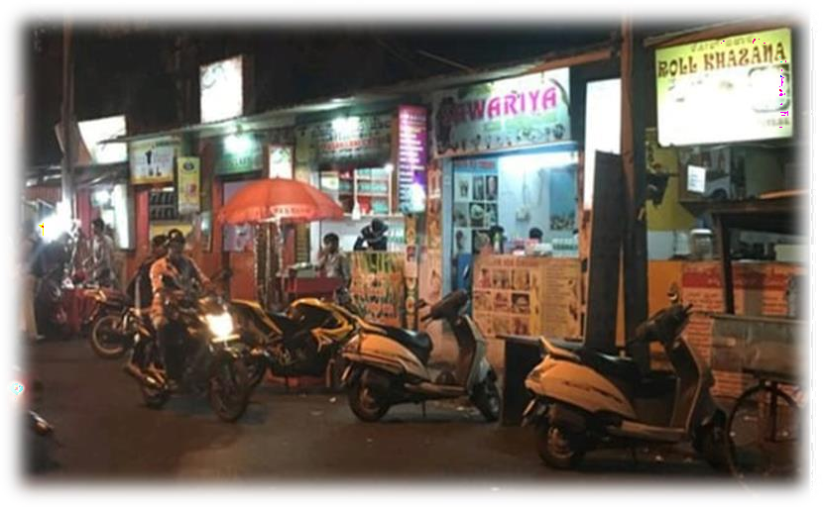
Figure5.2: Food Walk
You don’t always have to walk though. There could be variations. You can cycle your way down local restaurants, or use motorized transport such as a bus. In which case of course, it is a food trail and not a walk! The advantage of going on a food walk is that you get to try out loads of food, carefully chosen by resident food experts, and that you get to do so in a strategic manner. Walks like these typically last for two or three hours, during which, the person doing the food walk will take you to restaurants of their choice, which are usually eateries which best represent the food culture of the neighborhood that you might be visiting.

Dosa
A dosa, also called dosai, dosey, dwashi or dosha is a thin pancake in South Indian cuisine made from a fermented batter of ground black lentils and rice. Dosas are popular in South Asia as well as around the world. Dosas are served hot, often with chutney and sambar.

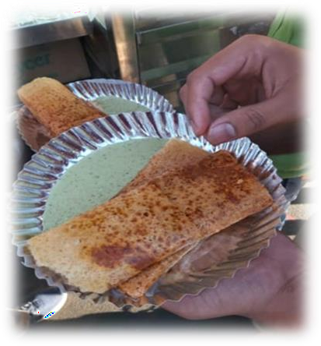
Figure5.3: Dosa

History
Dosas originated in South India, but its precise geographical origins are unknown. According to historian P. Thankappan Nair, dosa originated in the town of Udupi in present-day Karnataka. Acharya states that the earliest written mention of dosa appears in literature of present-day Tamil Nadu, in the 8th century, while the earliest mention of dosa in the Kannada literature appears a century later.
In popular tradition, the origin of the dosa is linked to Udupi, probably because of the dish's association with Udupi restaurants. The Tamil dosai is softer and thicker. The thinner and crispier version of dosa was first made in present-day Karnataka. A recipe for dosa can be found in Mansillas, a 12th-century Sanskrit encyclopedia compiled by Someshwar III, who ruled from present-day Karnataka.
After the Independence of India, South Indian cuisine became gradually popular in the North. In Delhi, the Madras Hotel in Connaught Place became one of the first restaurants to serve South Indian cuisine. It arrived in Mumbai with the Udupi restaurants in the 1930s.

Preparation
A mixture of rice and black or green gram that has been soaked in water is ground finely to form a batter. Some add a bit of soaked fenugreek seeds. The proportion of rice to lentils is generally 3:1 or 4:1. The batter is allowed to ferment overnight, before being mixed with water to get the desired consistency. The batter is then ladled onto a hot tava or griddle greased with oil or ghee. It is spread out with the base of a ladle or bowl to form a pancake. It can be made either to be thick like a pancake, or thin and crispy. A dosa is served hot, either folded in half or rolled like a wrap. It is usually served with chutney and sambar. The mixture of black grams and rice can be replaced with highly refined wheat flour or semolina.

Figure5.4: Plain Dosa

Nutrition
Dosa is high in carbohydrates and contains no added sugars or saturated fats. As its key ingredients are rice and black gram, it is a good source of protein. A typical homemade plain dosa without oil contains about 112 calories, of which 84% is carbohydrate and 16% protein. The fermentation process increases the vitamin B and vitamin C content.

Varieties
Basically, Dosa can be done in many forms of which the following are some of them, Masala dosa is a roasted dosa served with potato curry, chutney and sambar; while Saada (plain) dosa is prepared with lighter texture, paper dosa is a thin and crisp version. Rava dosa is made crispier using semolina. Newer versions are Chinese dosa, cheese dosa, paneer dosa, pizza dosa and so on.

5.35 vada pav
Vada pav, alternatively spelt vada pao, is a vegetarian fast food dish native to the Indian state of Maharashtra. The dish consists of a deep -fried potato dumpling placed inside a bread bun (pav) sliced almost in half through the middle. It is generally accompanied with one or more chutneys and a green chili pepper. Although it originated as an affordable street food in Mumbai, it is now served in food stalls and restaurants across India. It is also called Bombay burger in keeping with its origins and its resemblance in physical form to a burger. The most famous snack in Mumbai, vada pav is claimed to be a part of the culture of Mumbaikars.

Figure5.5: Vada Pav

Etymology
Batata vada in Marathi literally means "potato fritter". It is a combination of the word for "potato" (batata) and vada, a type of fried savory snack. Pav is a derivative of the Portuguese word pao, which means bread.

History
The most common theory of the vada pav's origin is that it was invented in the erstwhile mill- heartland of Central Mumbai. Ashok Vaidya of Dadar is often credited with starting the first vada pav stall outside Dadar railway station in 1966. Some sources credit Sudhakar Mhatre who started his business around the same time. One of the earliest kiosks selling vada pav is said to be Khidki Vada Pav, located in Kalyan. It was started in the late 1960s by the Vaze family, who used to hand out vada pavs from a window of their house facing the road. The

carbohydrate-rich snack catered to the cotton mill workers of what was then known as Giran- gaon. This potato dumpling (batata vada) placed inside a pav was quick to make, cheap (~10- 15 paisa in 1971), and much convenient over the batata bhaji and chapati combination, which couldn't be eaten in overcrowded local trains.

Preparation
A boiled potato is mashed and mixed with chopped green Chilli and garlic, mustard seeds, and spices (usually asafetida and turmeric). The mass is then shaped into a ball, dipped into gram flour batter and deep fried. The resultant fritter is served by placing inside a bread bun, accompanied with one or more chutneys and fried green Chilli.

Variations
Mumbai alone has many variations of the food based on the locality. Large fast food restaurant chains such as Kuhar Jumbo King in Mulund and Goli Vada Pav also primarily serve vada pav. Outside of Mumbai, a variant of vada pav is pav vada which is famous in Nashik. Annually, August 23 is celebrated as World Vada Pav Day.

Gobi Manchurian
Manchurian is a class of Indian Chinese dishes made by roughly chopping and deep- frying ingredients such as cauliflower (gobi), fish, and paneer, and then sauteing them in a sauce favoured with soy sauce. Manchurian is the result of the adaptation of Chinese cooking and seasoning techniques to suit Indian tastes. It has become a staple of Indian Chinese cuisine.
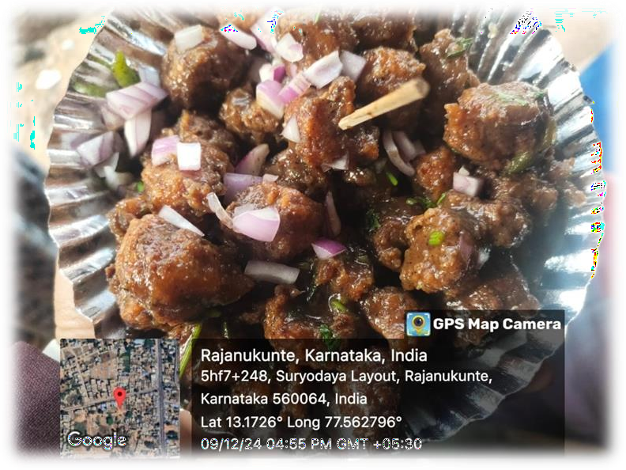
Figure5.6: Gobi Manchuria

History
The word "Manchurian" means native or inhabitant of Manchuria (around northeast China), but the dish is basically a creation of Chinese restaurants in India, and bears little resemblance to traditional Manchu cuisine. It is said to have been invented in 1975 by Nelson Wang, a cook

at the Cricket Club of India in Mumbai, when a customer asked him to create a new dish, different from what was available on the menu. Wang described his invention process as starting from the basic ingredients of an Indian dish, namely chopped garlic, ginger, and green chilis, but next, instead of adding garam masala, he put in soy sauce, followed by cornstarch and the chicken itself. A popular vegetarian variant replaces chicken with cauliflower, and is commonly known as gobi Manchurian. Other vegetarian variants include mushroom, baby corn, and veggie ball Manchurian.

Figure5.7: Gobi Manchurian

Variations
There are two different variants of Manchurian, dry or semi dry and with gravy. Both variants are prepared by using common ingredients like corn flour, Maida flour, spring onion, bell peppers, soy sauce, chili sauce, minced garlic, ground pepper, etc. and has typical garnish of spring onion. Some recipes call for use of monosodium glutamate (MSG) to increase the taste profile, though there are those who avoid it due to health concerns. Its taste can vary from mildly spicy to hot and fiery based on the recipe and personal preference.

Pani puri
Pani puri:(original name from Mahabharata times), gup-chap is a type of snack originating in the Indian subcontinent, where it is an extremely common street food.

Ingredients
Pani puri consists of a round hollow puri (a deep-fried crisp flatbread), filled with a mixture of flavored water, tamarind chutney, chili powder, chaat masala, potato mash, onion, or chickpeas. It uses spiced mashed potatoes as the filling. It is tangy rather than sweetish while the water is sour and spicy.

History
Chaat is considered the predecessor of pane - puri/. According to the culinary anthropologist Kurush Dalal, chaat originated in Northern Indian region of what is now Uttar Pradesh. He also noted that it possibly originated from Raj-Kachori: an accidentally-made smaller puri giving birth to pane puri. Pani puri spread to the rest of India mainly due to migration of people from one part of the country to another in the 20th century. Pane puri's origin can be traced back to ancient times. Many historians believe that pane puri has its roots in the Mughal era, while other argue that it was made in the Hindu temples, where it was used as an offering to the gods. Regardless of its origins, the dish became popular in the Northern regions of India during the early 20th century (it reportedly existed prior to 600 BCE), and it quickly spread to other parts of the country. It is argued that it originated from the Indian Kingdom of Magadha. This location of this Kingdom is now known as Southern Bihar.

Figure5.8: Pani Puri

Key Components:

Puris:
        - Small, crispy, hollow dough balls made from semolina or flour. They are fried until crispy and then hollow inside.
      - Pani (Water):
        - The water or liquid inside the puri, which is spicy, tangy, and flavored with tamarind, mint, coriander, black salt, cumin, and other spices. It’s typically chilled for a refreshing experience.

Filling:
        - The filling typically consists of boiled potatoes, chickpeas, mung beans, or other legumes. It can be spiced with various seasonings to add flavor.

Toppings:
        - Often includes ingredients like onions, coriander leaves, and a variety of spices. Some variations add yogurt or sweet chutneys to balance out the spicy water.

How It's Served:
- Pani Puri is served by either filling the puris with the water and other ingredients at the stall or giving the customer the option to dip the puris into the water themselves.
- The puris are typically eaten in one bite, providing a burst of flavor with a mix of textures (crispy, soft, spicy, and sweet).

Variations:
- Bhel Puri and Sev Puri are also popular variations of street snacks found in India, but they use different forms of serving (such as in a bowl, mixed with chutneys and puffed rice).
- Regional differences influence the preparation, with some areas adding unique twists, such as fruit or different spices.

Popularity:
Pani Puri is immensely popular across India and in countries with Indian diasporas. It is a common feature at food stalls, especially in markets, fairs, and on the streets. It's commonly eaten as a snack, and is often enjoyed with friends and family due to its fun, interactive nature.

Regional Names and Variations:
- Gol Gappa (North India, Delhi, Punjab, Rajasthan): The name "Gol Gappa" comes from "Gol," meaning round, and "Gappa," meaning bite. The round shape of the puri is emphasized.
- Puch-ka (West Bengal, Bihar, parts of Uttar Pradesh): The term "Puch-ka" is used for the puris and the water in West Bengal. While it’s made with the same basic ingredients, Puch-ka often has a spicier filling and water.
- Pani Ke Pata-se (Madhya Pradesh, some parts of North India): This term literally translates to "water-filled pastries."
- Pani Puri (Maharashtra, Gujarat, and other areas): In these regions, people often serve the puris in a "Pani puri set" which includes both sweet and spicy versions of the water, with fillings like potatoes and chickpeas.

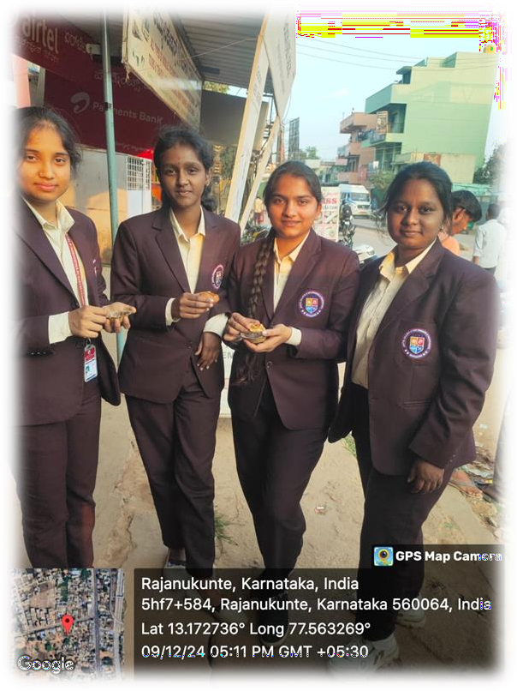
Figure5.9: Pani puri

Evolution
Pani puri has evolved significantly over time. Originally known as "Gol Gappa," the dish consisted of a small, hollow, fried wheat shell filled with spiced mashed potatoes and served with a tamarind or mint-flavored water. Overtime, variations of the filling and the flavored water emerged, reflecting the regional preferences and availability of ingredients. The flavored water, also known as the "Pani," is an essential component of the dish and is often the main source of flavor. Some of the most popular flavors of Pani puri include the traditional tamarind and mint water, as well as spicy variations like jalapeno or green chili water, and tangy flavors like lemon or tomato water. Some regional variations also use sweet flavors like fruit juices or dates. Pani puri is served with a range of fillings such as chickpeas, onions, and sprouts, and the flavored water can be made with a variety of ingredients such as lemon juice, jalapeno peppers, and fruit juices. The dish has also become more accessible, with pre-packaged Pani Puri shells and ready-to-use flavored water available in grocery stores. Pani puri is also known to be a byproduct of an older dish called Puck-ka

Ice Cream
Ice cream is a frozen dessert, typically made from milk or cream and flavored with a sweetener, either sugar or an alternative, and a spice, such as cocoa or vanilla, or with fruit such as strawberries or peaches. It can also be made by whisking a flavored cream base and liquid nitrogen together. Food colouring is sometimes added, in addition to stabilizers. The mixture is cooled below the freezing point of water and stirred to incorporate air spaces and to prevent detectable ice crystals from forming. The result is a smooth, semi-solid foam that is solid at

very low temperatures (below 2 °C or 35 °F). It becomes more malleable as its temperature increases.

Figure5.10: Ice Cream

History
In the sixteenth century, the Mughal Empire used relays of horsemen to bring ice from the Hindu Kush to its capital Delhi. The ice was used in fruit sorbets. It was also used to create kulfi, a popular frozen dairy dessert from the Indian subcontinent often described as "traditional Indian ice cream.

Composition
Ice cream is a colloidal emulsion made with water, ice, milk fat, milk protein, sugar and air. Water and fat have the highest proportions by weight creating an emulsion that has dispersed phase as fat globules. Ice cream must be at least 10 percent milk fat, and must contain at least 180 grams of solids per liter. When cocoa, chocolate syrup, fruit, nuts, or confections are added, the percentage of milk fat can be 8 percent. The ice cream mix is defined as the pasteurized mix of cream, milk and other milk products that are not yet frozen. It may contain eggs, artificial or non-artificial flavors, cocoa or chocolate syrup, a food colour, an agent that adjusts the pH level in the mix, salt, a stabilizing agent that doesn't exceed 0.5% of the ice cream mix, The ice cream mix may not include less than 36% solid components.

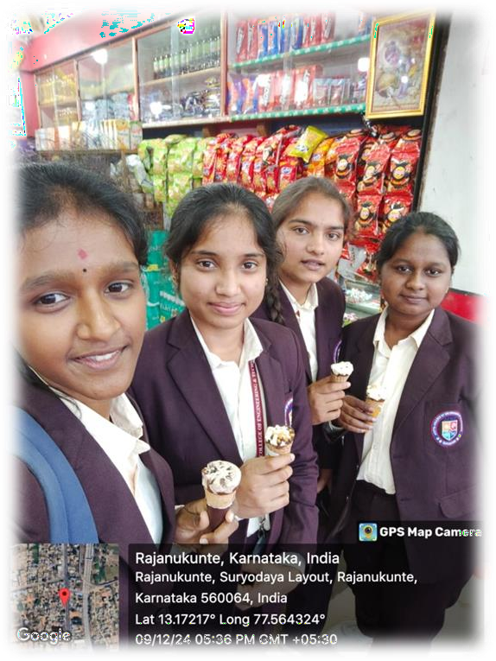
Fig5.11: Ice Cream

5.7. 3: Varieties
There are many different flavours of ice cream. Ice cream often has things added to it for flavours, like chocolate chips, nuts, fruit, cookie dough, sweets, sauces or small candies. Traditionally, the three most common flavours are vanilla, chocolate, and strawberry. There are ice cream flavours that are very similar, such as French vanilla, vanilla bean, dark chocolate, chocolate chip, and strawberry cheesecake. Chocolate chips, or little pieces of dark or white chocolate, are a common addition to ice cream. Three common chocolate chip ice creams are chocolate chip (made with vanilla ice cream), mint chocolate chip or mint 'n chip (made with peppermint, spearmint, or creme de menthe ice cream), and chocolate late chip. Peppermint ice cream without chips is also a common flavour. Many ice creams contain fruits. Besides strawberry, some citrus fruits, such as orange and lime, are made into sherbets instead of ice cream. There are many ice cream flavours that contain some mixture of chocolate, fudge, coffee, caramel, nuts, and marshmallows. The most common is Rocky Road (chocolate ice cream, nuts and marshmallows), but others include Mocha Almond Fudge (made with almond nuts, fudge, and coffee ice cream) and Tax Crunch (coffee, nuts, and malt powder). Some ice creams are a mixture of two or more ice creams. Neapolitan is a mixture of chocolate, vanilla, and strawberry; while spumoni is a mixture of chocolate and various fruit flavour

Paan (Betel-nuts)
Betel nut chewing, also called Pan is a practice in which areca nuts (also called "betel nuts") are chewed together with slaked lime and betel leaves. The practice is widespread in Southeast Asia, Micronesia, Island Melanesia, and South Asia. It is also found among the indigenous peoples of Taiwan, Madagascar, and parts of southern China. It has also been introduced to the

Caribbean in colonial times. The preparation combining the areca nut, slaked lime, and betel leaves is known as a betel quid (also called paan or pan in South Asia).

History
In a 16th-century cookbook, watches as tender betel leaves of the finest quality are spread out and rosewater is sprinkled on them, while saffron is also added. It is a tradition in South India and nearby regions to give two Betel leaves, areca nut (pieces or whole) and Coconut to the guests (both male and female) at any auspicious occasion. Even on a regular day, it is the tradition to give a married woman, who visits the house, two Betel leaves, areca nut and coconut or some fruits along with a string of threaded lowers. This is referred to as them bloom

Production
Betel leaf used to make paan is produced in different parts of India. Some states that produce betel leaf for paan include West Bengal, Bihar, Assam, Andhra Pradesh, Uttar Pradesh. In West Bengal, two types of betel leaves are produced. These are "Bangla Pata (Country Leaf)" and Mitha Pata (Sweet Leaf)". In West Bengal, Bangla pat is produced mainly in district of Dinajpur, Malda, Jalpaiguri, and Nadia. Mitha pat is produced in places such as Midnapur and South 24 Parganas.
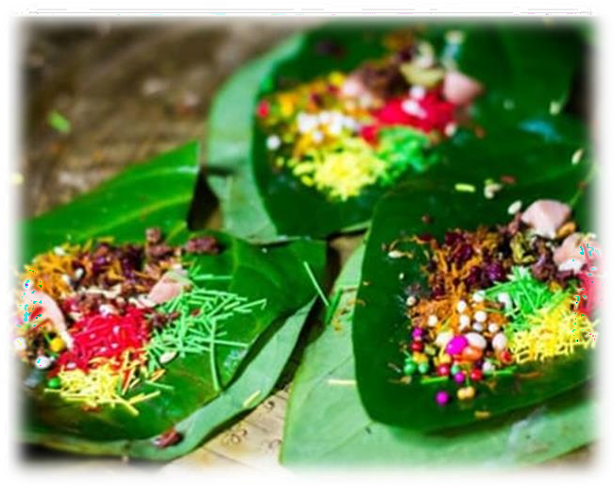
Figure5.12: Betel Leaf

Benefits
Betel leaves are commonly used as mouth fresheners in India. They are used as a base to wrap up various components of paan, including tobacco, betel nut, sugar syrup, and a few other components. Betel leaf extract has an extremely strong effect when it comes to healing wounds. This is because betel leaves are filled with antioxidants, which reduce the amount of oxidative stress your body is going through. When your body goes through high oxidative stress, it can delay the rate at which your wounds heal. Thus, betel leaves help with healing wounds. Furthermore, they are particularly effective against healing wounds that are related to burns. Diabetes is an extremely common disease and though there are numerous antidiabetic medications out there, it is best to avoid them as they often have side effects on the liver and

kidneys. Herbal remedies, such as betel leaf cures diabetes. Betel leaf can help reduce the overall glucose levels in your blood, which is great for people who have diabetes.

Conclusion
Food Walk is being done at the food Streets, here Street food is food or drinks sold by a hawker or vendor on a street or at other public places, such as markets, fairs, parks, and clubs. It is often sold from a portable food booth, food cart, or food truck and is meant for immediate consumption. Some street foods are regional, but many have spread beyond their regions of origin. Most street foods are classified as both finger food and fast food and are typically cheaper than restaurant meals.
The types of street food widely vary between regions and cultures in different countries around the world. According to a 2007 study from the Food and Agriculture Organization, 2.5 billion people eat street food every day. A majority of middle-income consumers rely on the quick access and cheap service of street food for daily nutrition and job opportunities, especially in developing countries. Today, governments and other organizations are increasingly concerned with both the socioeconomic importance of street food and its associated risks.
These risks include food safety, sanitation issues, and illegal use of public or private areas, social problems and traffic congestion. For the good health and safety measures to be taken the government of India has recognized the fundamental rights of the street food vendors and have imposed reasonable restrictions.
filled with antioxidants, which reduce the amount of oxidative stress your body is going through. When your body goes through high oxidative stress, it can delay the rate at which your wounds heal. Thus, betel leaves help with healing wounds. Furthermore, they are particularly effective against healing- wounds.

